|  |  |  |
| --- | --- | --- |
| **Problem Chosen** D | **2020 MCM/ICM Summary Sheet** | **Team Control Number** 2002470 |

**Research on Huskies’ teamwork from visualized and quantifying perspectives**

Football is one of the most popular sports in the world. What really attract audience are not only foot techniques or great games, it is the spirit of collaboration that encourages eleven players on the field, coaches and substitutes to win the game.

Several factors can affect the result of the game. For example, players’ personal abilities, team formation, couching level or even the weather may exert influence on the team’s performance. As introduced above, the meaning of football is teamwork. Therefore, all these indicators can be summarized as factors that affecting teamwork. In Huskies’ case, we obtain the detailed event data of 38 football matches, which describes players’ and team’s behaviors from multiple dimensions.

In the first part, we pay special attention on connections among players. Passes are the highest frequency events on the football field, and they directly indicate the player’s behaviors on the field. Network analysis helps to visualize the cooperating relations. Based on passing distance and times, we give weights to each edge and filter the high-scoring connection. The analysis covers micro to macro aspects, and we do find several key nodes and passing routes.

In the second part, we construct several indicators through different aspects to measure the performance of the teamwork. From the passing events, we use and renew the H indicator created by Paolo Cintia, et al. (2015) We not only consider the distribution among players and locations, but also time of the events. Then, we discuss the relationship between H indicator and the results of every match among the team and side. Furthermore, we get some information concerning individual’s performance such as failing to catch the ball ratio, passing ratio and the dribbling duration, detecting players who have a stronger and more comprehensive capacity to play the role. Later, we detect other information concerning full events and get a more comprehensive indicator for the individual player’s contribution in each match. Besides, we consider the defense and attack strategies and the defense and attack efficiency of the team by Pezzali score (Paolo Cintia, et al. ,2015) and two separated scores. We also get other information such as substitution strategy, structural strategy and duel rate.

With the features concerning matches, we use machine learning methods to create models illustrate the teamwork and predict the results of matches. We find XGBoost performs better than SVM, SGD, KNN and other methods.

In the later pages, we discuss the insight we get from the model and case. First, we give some advice to Huskies both on individual and team level. We find some outstanding players, but the conclusion is the significance of the cooperation. Besides, the position is still a problem. Then, from the team perspective, we select several important indicators, especially for Huskies to improve. Finally, we conclude the key points to improve the team performance generally, such as teamwork, everyone’s duties, special strategies and weaknesses. With the full understanding of both ourselves and competitors’, can we improve in the future competition.

**Keywords: Team Network; Player Performance; Team Strategy; XGBoost**

**TABLE OF CONTENTS**

1 PASSING NETWORK ANALYSIS 1

1.1 ASSUMPTION 1

1.2 MODEL SETTING 1

1.3 DYADIC CONFIGURATIONS 3

1.4 TRIADIC CONFIGURATIONS 4

1.5 TEAM FORMATION 5

1.6 HEATMAP OF PASSING ROUTE 7

2 TEAM PERFORMANCE ANALYSIS 8

2.1 PASSING EVENTS AND H INDICATOR 8

2.2 COMPREHENSIVE PERFORMANCE OF EACH PLAYER 10

2.3 PLAYERS’ PERFORMANCE AND CONTRIBUTION IN EACH MATCH 12

2.4 HUSKIES’ ATTACK-DEFENSE STRATEGY AND PEZZALI SCORE 14

2.5 SUBSTITUTION STRATEGY AND ITS EFFECT 15

2.6 DUEL RATE 16

2.7 MODELS CAPTURING THE FEATURES OF THE TEAMWORK 16

3 ADVICES FOR HUSKIES 17

3.1 VIEWS ON PLAYERS 17

3.2 VIEWS ON THE TEAM STRATEGY 18

4 KEY INDICATORS TO IMPROVE TEAM’S PERFORMANCE 19

4.1 TEAMWORK 19

4.2 PERFORM THEIR DUTIES 19

4.3 PLAY BY EAR 19

4.4 FURTHER EVALUTATION MEAN 19

4.5 WEAKNESS OF THE TEAM 20

REFERENCE 20

APPENDIX——CODE (BASE ON PYTHON3) 21

TEAM FORMATION ANALYSIS 21

HEATMAP 23

DYADIC CONFIGURATIONS 25

TRIADIC CONFIGURATION 28

EACH MATCH FORMATION 30

H-INDEX 33

FULL EVENT ANALYSIS 38

MACHINE LEARNING MODELS 51

1. **PASSING NETWORK ANALYSIS**

In a football match, players take passes from teammates and pass the ball to others. When the ball comes near to the goalmouth, one of these players takes the chance to shot and goal! It’s the passing process that contributes to the goal. To make each goal attempt, the team must pass the ball from backcourt, get rid of opponent interruptions and send it to the front. Therefore, it’s significant to evaluate the team performance by analyzing its ball passing process.

Conjoint analysis asks researchers considering more indicators. passing analysis shouldn’t be focused on ball only. For example, passes are initiated by football players. In this case, we take players, passing routes, distance, time etc. into consideration. Creating network helps to visualize those passing records and provides us with a comprehensive view on the team performance.

* 1. **ASSUMPTION**
     1. Successful pass is in the same data line where origin player and destination player belong to the same team. If the origin player is different from previous destination player in the next data line, it can be seemed as an offense-to-defense or defense-to-offense transition.
     2. Players have preferences of position on the football field, and the position preference is unchangeable. A football team consists of forwards, midfielders, defenders and goalkeeper. In most cases, forwards won’t play the role of defenders, and vice versa. Player’s properties decide his style. Left-footed players are more outstanding when break through from the left-hand side than the right side. Base on it, they rarely appear on both sides. Arithmetic average positions can represent players’ active areas.
     3. Passing process has directions. Player A passes the ball to Player B, A and B have some connections to some extent. In some situations, the calculation of strength of the connection can ignore directions. However, when it comes to some research areas, directions are nonnegligible.
     4. Pass is essential to estimate players performance. A key player should have high number of passes. On one hand, passing becomes a hub of communications between backcourt and frontcourt. On the other hand, it shows the trust from teammates. Players hardly pass the ball to those poor performance players.
     5. Sizes of the football fields are all standardized. The size is specified as 105m length and 65m width, same as World Cup’s regulation. The dataset provides with proportional scale which needs to be adjusted to actual scale.
  2. **MODEL SETTING**

We draw several network structures to describe the passing process, mainly using the package named “Networkx”, in Python. Network structure is made up from nodes and edges. Nodes are football players and edges are the connections among them.

Nodes represents players’ locations and roles. In order to distinguish different nodes’ effect, the sizes of nodes are set to be proportionate with players’ passing times. The passing times here are added up by two forms of passing process. Taking the ball from others and passing the ball to others are two different but related motions.

The connections among football players are presented by edges. Link between two players contains the following information. Firstly, length of the link is proportionate with players’ real average distance. Second, although arrow do not point out the exact passing direction, it still indicates whether the ball pass from Player A to Player B or from Player B to Player A. Third is absolute passing times. Edges’ transparency level is used to describe the passing times. Lower absolute passing times are corresponding to more transparent line. Lastly, edges’ width represents connection weight.

Edges’ weight is the indicator of connection strength. Absolute passing times can partly express connection strength. However, several factors can still affect the strength. It’s common sense that long balls are more difficult to catch. Players who deal with long ball are usually highly skilled. Figure1 shows the distribution of passing times over distance. Short passes occupy the main position. The most passes are made within range from 12 to 15 meters. Furthermore, successful rates of different distance passes are calculated as orange line shown. For short passes, which are made within 25 meters, have higher successful rate around 0.80 ~ 0.85. As the distance increases, the successful rate goes down drastically. Though in some distance ranges, the rate goes back above 0.6 level. There are two explanations. Number of long balls is quite small, which exists occasional situations. Besides, long passes sometimes efficiently can break opponent defense and result the increase of the successful rate.

Edges show the connection between players and consist of all their inner passes. Successful rate is the direct indicator to estimate the passing process and could be used as weight. We give weights to each pass, depending on the distance and add them up. For those passes distances are larger than 50, we use average weight to exclude the interference from occasions.

Based on assumptions, data, indications mentioned above, we draw dyadic, triadic configurations to have comprehensive looks on players collaboration. For some significant links, we do pay additional attentions. Besides, in macro views, team’s formation and active areas are taken into consideration as well.

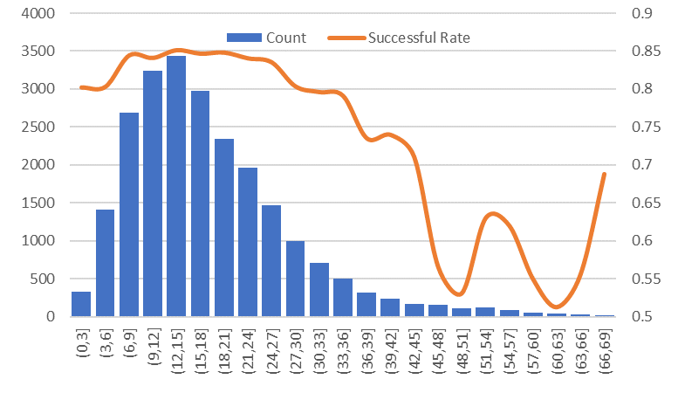

Figure 1 Distribution of passing distance and successful rate

* 1. **DYADIC CONFIGURATIONS**

Dyadic collaboration is the most common way. We define it as a process which happens from Player A to Player B with direction. To identify Huskies’ main pass routes, all edges weights are calculated and Top 16 are screened out as figure 2 shown below. “#1” means connection pointed from M1 to F2 ranks one. Still can find out that the connection from F2 to M1 ranks five. The connection between two same nodes can be different in weights which presents in the width of the edges. Table 1 provides detailed information about Top16 edges and their nodes.

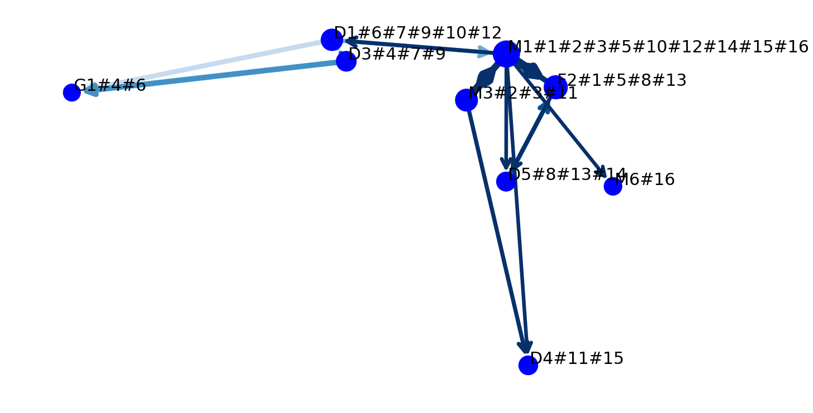

Figure 2 The dyadic network with weight ranking in the Top16

We can see from Figure2, high ranking pass routes are mainly center on midfield and backcourt. Three midfields, five defenders, one goalkeeper and only one forward are in the list. Passing behaviors can be seemed as midfield transfer and sometimes knock the ball back. Only two links #1#8 are pointed to the forward. These indicate that Huskies may take conservative strategy instead of straight forward. D4 is the only player who is active on the right wing, taking ball from M3 and M1. Taken as a whole, Huskies has mature midfield players and pass awareness. However, it’s both an advantage and defect for the team. Too many players are crowed in the midfield which leads to the lack of attacking roles. In Top15 list, we can’t see any left side players or pass routes.

Table 1 Detailed information about Top16 dyadic collaborations

|  |  |  |  |  |  |  |  |  |
| --- | --- | --- | --- | --- | --- | --- | --- | --- |
| Rank | Origin Player | Destination Player | Weight |  | Rank | Origin Player | Destination Player | Weight |
| 1 | Huskies_M1 | Huskies_F2 | 151.44 |  | 9 | Huskies_D3 | Huskies_D1 | 79.24 |
| 2 | Huskies_M3 | Huskies_M1 | 140.46 |  | 10 | Huskies_D1 | Huskies_M1 | 76.57 |
| 3 | Huskies_M1 | Huskies_M3 | 119.20 |  | 11 | Huskies_M3 | Huskies_D4 | 73.25 |
| 4 | Huskies_D3 | Huskies_G1 | 98.55 |  | 12 | Huskies_M1 | Huskies_D1 | 70.34 |
| 5 | Huskies_F2 | Huskies_M1 | 97.13 |  | 13 | Huskies_F2 | Huskies_D5 | 68.94 |
| 6 | Huskies_D1 | Huskies_G1 | 88.80 |  | 14 | Huskies_M1 | Huskies_D5 | 65.66 |
| 7 | Huskies_D1 | Huskies_D3 | 85.81 |  | 15 | Huskies_M1 | Huskies_D4 | 64.89 |
| 8 | Huskies_D5 | Huskies_F2 | 80.99 |  | 16 | Huskies_M1 | Huskies_M6 | 64.02 |

It’s indisputable that M1 plays the key role in the network. As a midfield player, he takes the responsibility to catch a ball and try his best to send it to the front. Therefore, in the Top16 list, M1 occupies nine positions.

M1 to F2 pass route has the highest weight, so it deserves special attention. Figure3 draw this connection’s changing process over match time. Each line is corresponding to a single match. X axis shows the time counted in second and Y axis record how many times M1 pass the ball to F2. Considering players might perform differently in the first half and second half, so the chart is divided into two parts. The colored line crosses dotted average line means, in that match, the pass connection reaches average level. The green line and blue line are higher than others and happen in the sixth and fifth matches. Before the second half begin, M1 has already pass the ball to F2 more than 10 times. However, as the season goes on, the total passing times goes down. In this situation, M1 can still finish half average level passes in the first halt, but in the second half the passing process grows slowly. In the late period of the season, the passes number start to grow up again. In 27th, 28th matches, the time used to reach average level is shortened obviously.

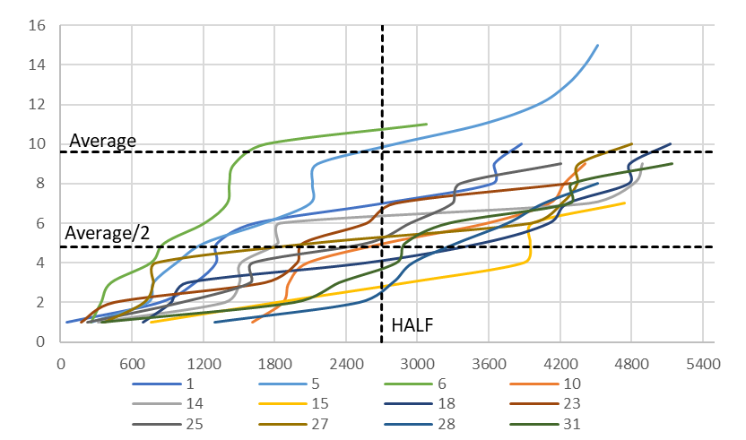

Figure 3 M1 to F2 passing count over time

* 1. **TRIADIC CONFIGURATIONS**

Triadic collaboration is more complex than dyadic. Triadic collaboration requires higher level of teamwork. Triadic connection is not three simple nodes and their edges. We define triadic collaboration is a process with continuous passing direction and target. For example, “A->B->C” is a triadic collaboration. Even though the connection “A->B<-C” has three nodes, this passing mode does not make any progress in the game.

Figure4 and table2 give the network and detailed information about Top8 Triadic collaboration. It seems that the Huskies’ strategies are clear. Midfield players are the most important role in the team. Defenders prefer to send the ball to midfield players instead of directly pass to the frontcourt. Midfield players act as organizers. They take the ball from defenders, pass around the midfield and finally pass it to the forward. Player F2 is the essential attacking power. He only catches the ball from M1, which is corresponding to the result of dyadic analysis above. It’s amazed to find that, in Top8 connections, M1 participates all the passing process. We are more firmly believing that M2 is dispensable in Huskies.

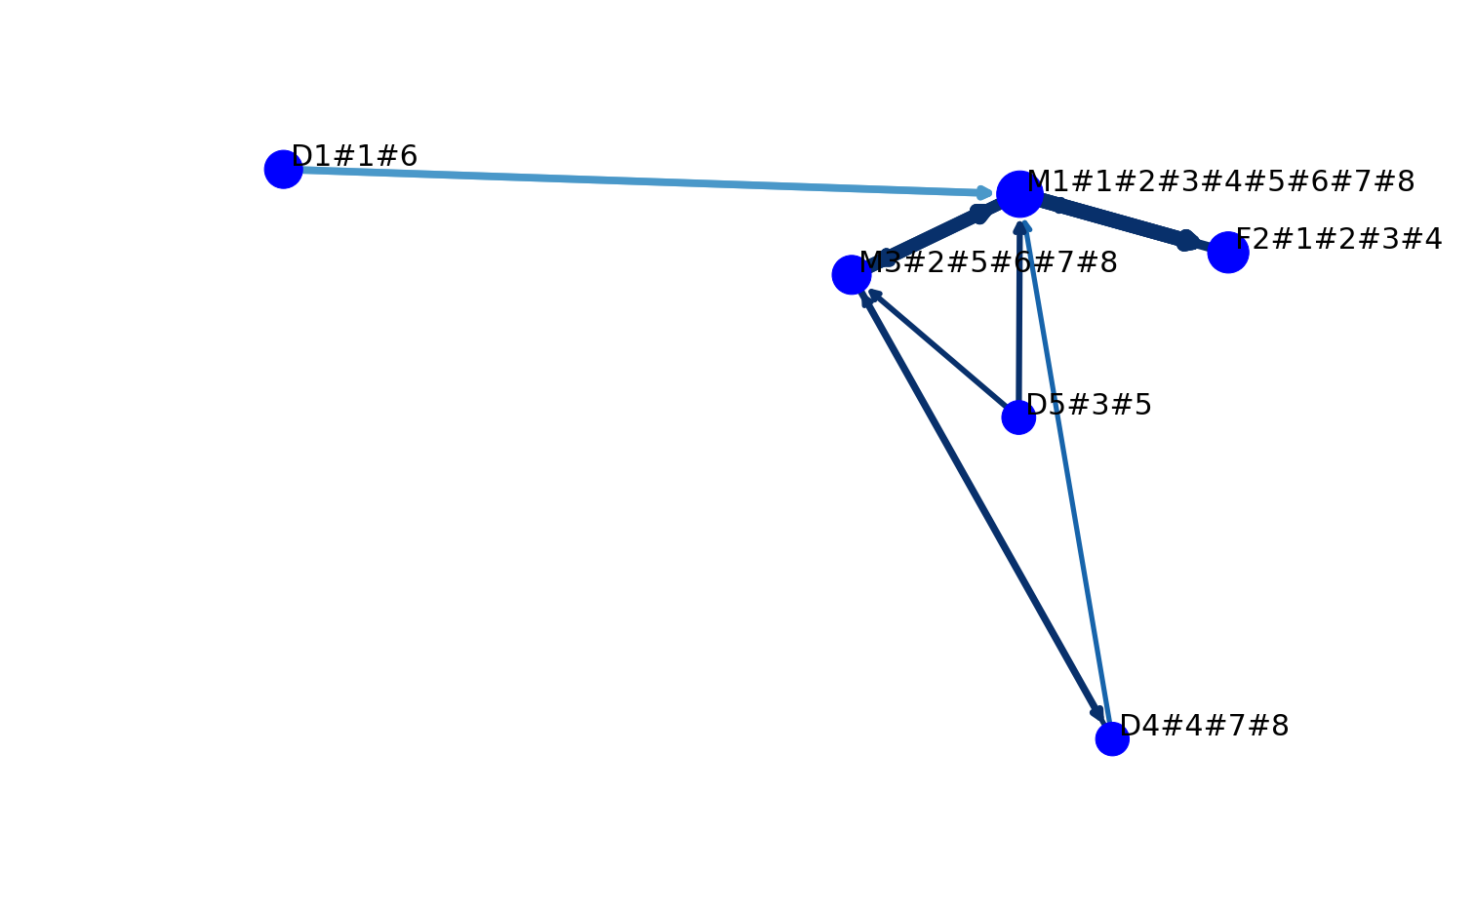

Figure 4 The triadic network with weight ranking in the Top 8

Take another look at table2, triadic weight is added by two edge weights. The first edge weights are usually much smaller than the second. In first edges, midfield player M1 and M3 take all the places of destination player. On one hand, it proves the important of midfield. On the other hand, these single routes exert too much pressure on few players.

Table 2 Detailed information about Top8 triadic collaborations

|  |  |  |  |  |  |  |  |
| --- | --- | --- | --- | --- | --- | --- | --- |
| Rank | Origin Player1 | Destination Player1 | Edge1 Weight | Origin Player2 | Destination Player2 | Edge2 Weight | Triadic Weight |
| 1 | Huskies_D1 | Huskies_M1 | 76.57 | Huskies_M1 | Huskies_F2 | 151.44 | 228.02 |
| 2 | Huskies_F2 | Huskies_M1 | 97.13 | Huskies_M1 | Huskies_M3 | 119.20 | 216.33 |
| 3 | Huskies_D5 | Huskies_M1 | 62.57 | Huskies_M1 | Huskies_F2 | 151.44 | 214.02 |
| 4 | Huskies_D4 | Huskies_M1 | 51.86 | Huskies_M1 | Huskies_F2 | 151.44 | 203.30 |
| 5 | Huskies_D5 | Huskies_M3 | 57.65 | Huskies_M3 | Huskies_M1 | 140.46 | 198.10 |
| 6 | Huskies_D1 | Huskies_M1 | 76.57 | Huskies_M1 | Huskies_M3 | 119.20 | 195.78 |
| 7 | Huskies_D4 | Huskies_M3 | 52.75 | Huskies_M3 | Huskies_M1 | 140.46 | 193.20 |
| 8 | Huskies_M1 | Huskies_M3 | 119.20 | Huskies_M3 | Huskies_D4 | 73.25 | 192.45 |

* 1. **TEAM FORMATION**

Dyadic and triadic analysis provides us with individual and micro views to estimate players behaviors. The shift of perspective from micro view to macro view will help us identify Huskies’ formation. Here we use undirected graph.

There are 30 players in Huskies, some of them are major force while others are on the bench. We put 30 players on the picture at one time, as figure5 shown below. Each node represents the player average position in the whole season. To identify different players’ contribution, the nodes sizes mark their total passing times.

In figure5, we can see that the midfield players are crowed in the center of the whole field. Imagine a line from Huskies’ goal to opponent goal, over 20 players are near to the line. It shows that Huskies pays much attention on middle attack. It’s not a good thing for a team to have only one main line of attack. On the left wing, although there are 3 to 4 players active in that area, they are mostly defenders. Defenders cross through to middle court will cause troubles. Firstly, they have no advantage in speed and breakthrough skills competing with opponents. Secondly, defenders go deep into the front court will lead to the vacancy of own backcourt. Defenders hardly make himself back immediately. The same problem exists on the right wing. There is only D4 standing on the right side and no one acts as his substitution. From our point of view, Huskies is lack of deployment on the right side. Then comes to the frontcourt. There are two main kind of forwards. Some like F2 who establish steady connection with midfield players but stay very far from opponent goal. The others, take F4 as an example, stand close to the goal but hardly take the ball from midfield players. All these problems will weaken Huskies’ power of offending and defending.

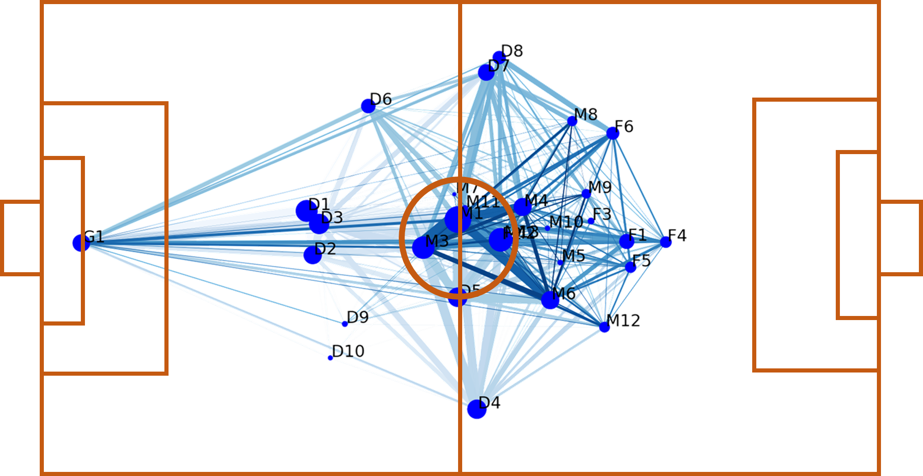

Figure 5 Whole team passing network

We randomly choose some attacking routes and create images from Huskies sides and the opponent. We define attacking route as each successful shot and ten steps back. In match 31st, it shows that Huskies’ player takes the ball from opponent and send it back to own midfield players. And midfield players transfer it several times and seize the opportunity to pass the ball to the left side. And look at the match 14th, Huskies’ player passes the ball from own backcourt to midfield and midfield players are responsible to initial an attack. In two images, we can see some same phenomena. In Huskies, midfield players play the most important role and other players will also pass the ball to them when take a ball no matter where.

In match 32nd and 27th, the images below describe opponents attacking routes. It’s clear that they prefer to pass the ball and break through from both sides instead of the middle. In match 27th, even if the opponent wants to pass the ball from left side to right side, they avoid passing the ball to midfield but directly sent a long ball to the right side. Huskies performs well in midfield and opponent will try not to scramble the ball in that area.





Figure 6 Example of Huskies and opponents attacking routes

* 1. **HEATMAP OF PASSING ROUTE**

Team formation above shows different position players’ contribution in Huskies. However, the players are always keep running, the image can’t explain each pass. We draw a heatmap to describe Huskies’ passes situation. The deeper the color, the area initiates more passes. We can see from the figure7 that most passes happen in backcourt. The left and right sides have higher heat level than the center, which is different from figure5. Figure5 reflects players average positions. In real matches, players will move to other areas to take and pass the ball. Therefore, heatmap can better express the pass event. In Huskies’ backcourt, where happens the most pass events, balls are hard to be transfer to the middle. There are few points in the frontcourt. Huskies does have trouble in breaking opponent’s defense. Although left and right sides are somehow active, midfield is not animate as we assume before. Opponent will avoid these areas on purpose which leads to midfield player having no chance. In addition, the wing players are mainly defenders who are lack of ability to pass the ball. It means that the chance possibly lost in two wings.

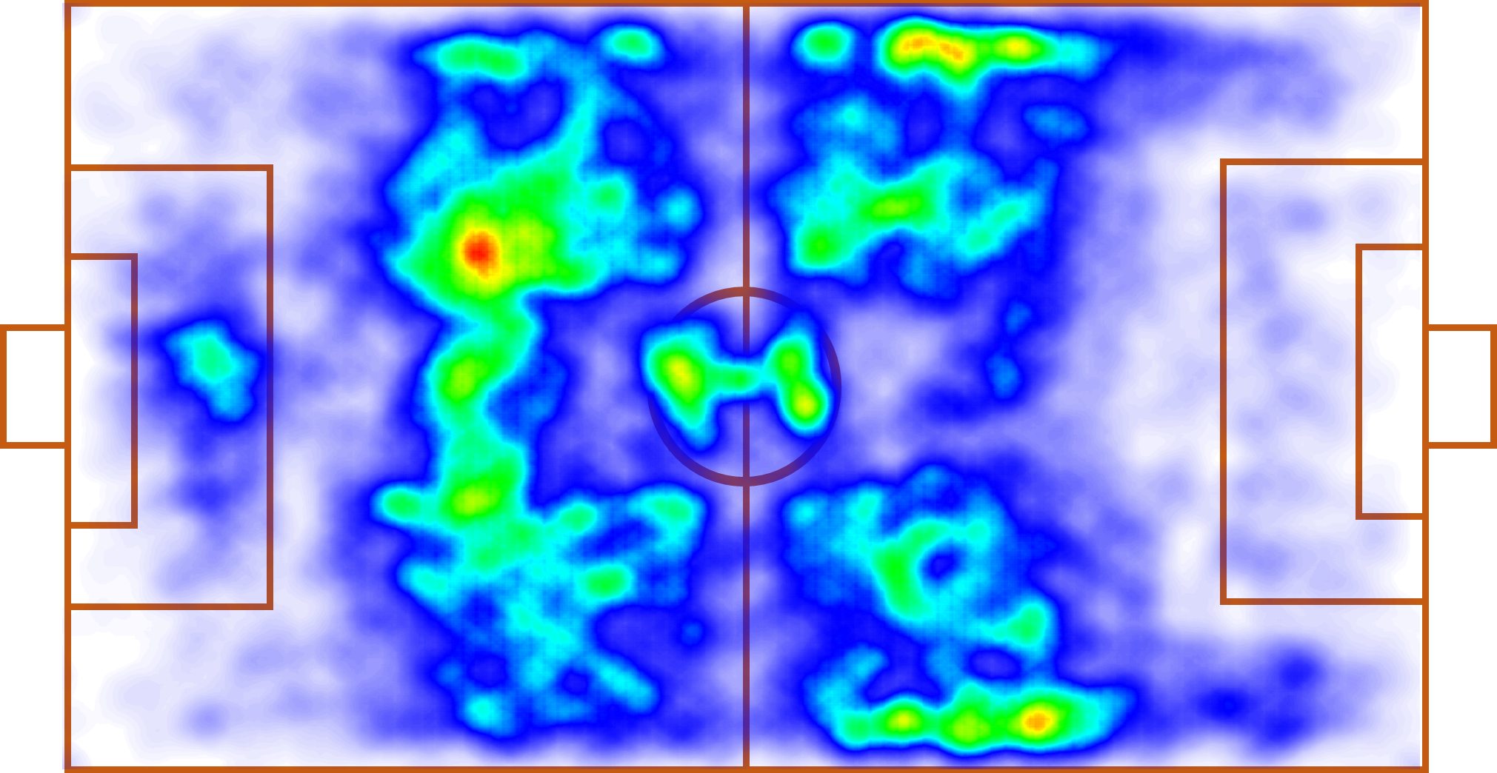

Figure 7 Heat map of Huskies passing routes

1. **TEAM PERFORMANCE ANALYSIS**
   1. **PASSING EVENTS AND H INDICATOR**

In the analysis of the passing events, we focus on not only the volume of a team in an individual game, but also the distribution of the passing events over different players, locations and time.

First, we count the volume of passing events ω of Huskies and his opponents in every match. From the Figure8 (a), we can see a strong correlation between the pass events and shot events in both Huskies and opponents. And, we also plot the scatter of score they gained in the Figure8 (b), maybe we cannot see an evident positive correlation between them. But we can tell that the average passing volume of Huskies is much lower than its opponents, the same in the shot volume and score they gained. In short, we assume that the main strategy of Huskies is defense according to the passing events.

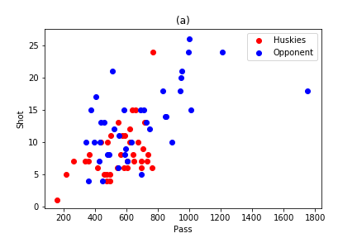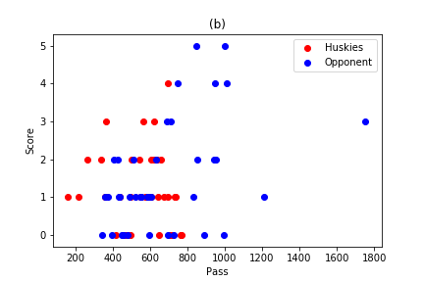

Figure 8 Scatter of passing volume and (a) shot volume; (b) score

Second, we get deeper analysis about the distribution of the passing events. By counting the passing events in every player, we can get the information concerning the players’ performance comparing their teammates. Besides, we can detect if the team’s strategy is based on several players or the whole team’s cooperation. The same to the counting volume divided by locations and time. We divide the court into 25 parts, by dividing its x-coordinate and y-coordinate ranging [0,100] into 5 parts with ranging 20 for every single past. Then, we count the passing events happening in every part. Similarly, we divide the event time into 16 parts for a whole match, 8 for a half with 5 minutes in a part.

According to the statistics we get above, we can calculate the mean and standard deviation of the passing events’ distribution in every match denoting with $μ_{P}$, $σ_{P}$ for players’ distribution, $μ_{L}$, $σ_{L}$ for the location and $μ_{T}$, $σ_{T}$ for time. Then, we combine all of the seven indicators above by their harmonic mean $H=7/(1/ω+1/μ_{P}+1/σ_{P}+1/μ_{L}+1/σ_{L}+1/μ_{T}+1/σ_{T})$ to measure the team’s whole performance during the match[1].

Besides, we plot the relation between H indicator and shot and score they gained in the Figure 9. It is not so different from the plot in Figure 8 and correspond with what we get above.

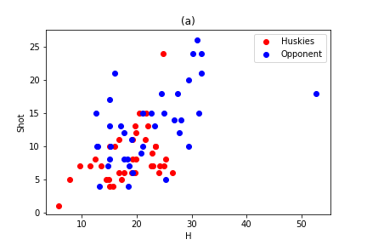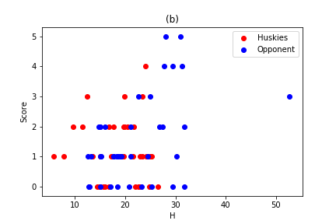

Figure 9 Scatter of H indicator and (a) shot volume; (b) score

Table 3 Measures and description

|  |  |
| --- | --- |
| Measure | description |
| $$ω$$ | Total passing volume in every match |
| $$μ_{P}$$ | Mean of players’ passing volume |
| $$σ_{P}$$ | Standard deviation of players’ passing volume |
| $$μ_{L}$$ | Mean of locations’ passing volume |
| $$σ_{L}$$ | Standard deviation of locations’ passing volume |
| $$μ_{T}$$ | Mean of time’s passing volume |
| $$σ_{T}$$ | Standard deviation of time’s passing volume |
| $$H$$ | Combination of measures above |

Table 4 Correlation between measures and shot and score in different team

|  |  |  |  |  |
| --- | --- | --- | --- | --- |
| Measure | Shot_Hus | Shot_Opp | Score_Hus | Score_Opp |
| $$ω$$ | 0.472 | 0.595 | -0.059 | 0.444 |
| $$μ_{P}$$ | 0.476 | 0.611 | -0.039 | 0.436 |
| $$σ_{P}$$ | 0.528 | 0.476 | -0.021 | 0.423 |
| $$μ_{L}$$ | 0.487 | 0.558 | -0.058 | 0.435 |
| $$σ_{L}$$ | 0.324 | 0.505 | -0.135 | 0.423 |
| $$μ_{T}$$ | 0.457 | 0.573 | -0.057 | 0.416 |
| $$σ_{T}$$ | 0.381 | 0.395 | 0.097 | 0.455 |
| $$H$$ | 0.439 | 0.527 | -0.016 | 0.470 |

In the Table 4, we calculate the correlation between shot and score in different and the measures we get above. According to the result, we can see that the correlation between shot and the measures in opponents is higher than Huskies’ evidently, which means opponents shot more in a single match with the same amount of passing event. The same result when we see the correlation between score and the measures. The correlation in Huskies even becomes negative comparing the positive results in the opponents’, which means more passing events in Huskies may even results in lower score.

Then, we compare the H indicator in different team in Figure 10. The red dots mean Huskies win the match and the black one means lose and the blue one means tie. The line in the middle of the plot means the same H value in both sides. From the plot, we can see in most of the match Huskies wins they have a higher or approximately equal H value than opponents. However, they cannot win match with higher H value of themselves. In 15 matches which they possess a higher H value, only 46.6% they win. What’s more, in the northwest part of the plot, there are no red dots, which means Huskies cannot win the opponents with a much higher H than them.

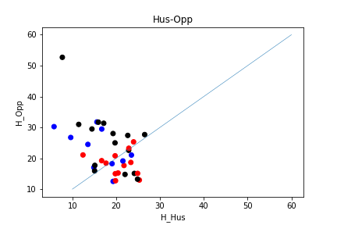

Figure 10 H indicator in different teams

From the Figure11, we compare the H value of home side and away and the red dot mean the home side wins, so does the blue dot and black dot. We can see the side is also a significant factor to be considered. Most of the black dots scatter around the line and northwest part, which means the away side team with approximate H value hardly can win but the home side is much easier to do so.

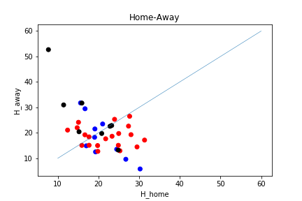

Figure 11 H indicator in different sides

* 1. **COMPREHENSIVE PERFORMANCE OF EACH PLAYER**

We measure the comprehensive performance of each player in the team of Huskies in three aspects including the ratio a player failing to catch the ball passed from teammates, the time a player dribble the ball after he catch the ball passed from teammates, the ratio a player passing the ball to other teammates after he gets the ball. The first indicator measures a player’s skill in stopping and catching a ball, while the rest indicator measures how the player acts after getting the ball and the influence of his performance on the teamwork.

The ratio a player failing to catch a ball is constructed in the following way. We record the time when a passing occurs and then find the next event. If in the next event, a player of opponents rather than Huskies holds the ball, we define the passing as an event where the player supposed to be the destination one fails to catch the ball. Then we calculated ratio of the amount of failed passing to the aggregate amount of passing for each player, called the ratio a player failing to catch a ball. The result is exhibited in the graph below.



Figure 12 Ratio of Huskies’ players failing to catch the ball passed from teammates

As shown in the graph, we can see that, 73.33% of the players can catch the ball at the ratio less than 2%, which is at a low level. However, there exist a problem that the ratio of forward is high compared with that of defense and midfield, which indicate that the forward of Huskies needs more practice in passing otherwise may badly affect the attack of the team.

We also calculate the dribbling time, the duration between passing and the next event. The results are shown as below. We can conclude that 93.33% of the players pass the ball to teammates after he gets the ball in no longer than 4 seconds. As a goalkeeper, the player whose ID is G1 sometimes has to wait for a better chance to pass the ball to his teammates, and it is reasonable that he does not pass the ball in a short period. However, M10, a midfield who fail to catch the ball at ratio of 8.696% also dribbles for an average longer time than other midfield, which means that during the match he cannot handle things well and find the right time to pass the ball to his teammates immediately. His hesitation may do damage to the teamwork. In conclusion, the midfield M10 needs more practice to be a skilled player.



Figure 13 The time Huskies’ players dribble the ball after catching the ball passed from teammates

The ratio a player passing the ball to other teammates after he gets the ball reflect one’s effect on the liquidity of the teamwork. As shown below, we find that the passing ratio of most defense and midfield players are high, which benefits the liquidity of the teamwork, while that of most forward players are relatively low because the forwards need to shot a goal and do some other things. However, M10 appears among player with low ratio again, testing that he does badly in regard with teamwork.



Figure 14 Ratio of Huskies’ players passing the ball to other teammates after getting the ball

* 1. **PLAYERS’ PERFORMANCE AND CONTRIBUTION IN EACH MATCH**

We do analysis similar to part 2.2 based on the perspective of each match. We calculate the average ratio of Huskies’ players failing to catch the ball passed from teammates, the average time Huskies’ players dribble the ball after catching the ball passed from teammates, the average ratio of Huskies’ players passing the ball to other teammates after getting the ball.

Table 5 Players’ average performance in each match

|  |  |  |  |  |  |  |  |  |  |
| --- | --- | --- | --- | --- | --- | --- | --- | --- | --- |
| Match | FailCatch | Dribble | Pass | Result | Match | FailCatch | Dribble | Pass | Result |
| 1 | 0.54% | 2.655 | 85.48% | win | 20 | 0.86% | 2.770 | 73.39% | tie |
| 2 | 1.64% | 2.534 | 76.50% | tie | 21 | 1.08% | 2.870 | 76.69% | loss |
| 3 | 0.31% | 2.931 | 87.46% | loss | 22 | 0.00% | 2.657 | 76.86% | loss |
| 4 | 0.28% | 3.040 | 81.79% | loss | 23 | 0.42% | 2.675 | 79.50% | loss |
| 5 | 0.00% | 2.544 | 80.26% | loss | 24 | 0.31% | 2.754 | 80.80% | tie |
| 6 | 0.31% | 2.880 | 81.62% | win | 25 | 0.40% | 2.567 | 71.03% | win |
| 7 | 0.78% | 2.739 | 74.94% | loss | 26 | 0.69% | 2.977 | 76.90% | loss |
| 8 | 0.34% | 2.782 | 82.89% | tie | 27 | 0.70% | 2.987 | 75.52% | win |
| 9 | 0.00% | 2.871 | 79.55% | loss | 28 | 0.83% | 2.604 | 68.88% | loss |
| 10 | 0.28% | 2.608 | 78.45% | loss | 29 | 6.75% | 2.379 | 66.67% | loss |
| 11 | 2.05% | 5.278 | 73.33% | win | 30 | 0.32% | 2.705 | 76.83% | win |
| 12 | 0.73% | 2.482 | 83.21% | tie | 31 | 0.60% | 2.750 | 80.42% | win |
| 13 | 1.53% | 2.407 | 66.28% | loss | 32 | 0.00% | 3.294 | 83.04% | loss |
| 14 | 0.00% | 2.523 | 74.29% | win | 33 | 1.43% | 2.759 | 78.10% | tie |
| 15 | 1.06% | 2.613 | 67.61% | win | 34 | 0.29% | 2.835 | 77.29% | tie |
| 16 | 1.20% | 2.376 | 69.88% | tie | 35 | 0.57% | 2.601 | 84.86% | win |
| 17 | 0.00% | 2.510 | 82.74% | win | 36 | 0.66% | 2.451 | 71.80% | win |
| 18 | 1.25% | 2.699 | 84.38% | win | 37 | 0.34% | 2.756 | 75.34% | tie |
| 19 | 0.40% | 2.538 | 68.53% | tie | 38 | 0.72% | 2.763 | 77.70% | loss |

We can see from the table5 above that most of the average player dribbling time is within the range of [2.376, 3], and the result of a match with a greater average player dribbling time is inclined to be loss, like the match 4 and 32. Similarly, we can summarize that the result of a match with a greater average ratio players passing the ball to his teammates and a lower ratio players fail to catch the ball is inclined to be win. The three factors impose influence on the liquidity of teamwork, which is positively correlated with the possibility of winning the game.

Table 6 Weight of different kinds of events to calculate players’ contribution

|  |  |  |  |
| --- | --- | --- | --- |
| event | weight | event | weight |
| Foul | -2 | Pass | 1 |
| Duel | 3 | Others on the ball | 1 |
| Offside | -1 | Free Kick | 2 |
| Shot | 3 | Substitution | 0 |
| Goalkeeper leaving line | 1 | Interruption | -1 |
| Save attempt | 2 |  |  |

From another perspective we design an indicator to analyze the distribution of players. The indicator is a weighted average with regard to the events the players involved, and we normalize the indicator to keep the value of contribution is within the range of [0, 1]. Considering that not every player participated in every match, we calculate the average contribution of each player’ contribution to matches he participated. As shown in the graph, we find that the midfield M1 contributes most, which accords with the analyze in part 1.3-1.4. The players with a large contribution are generally midfield and defense, which means that Huskies has more advantage in defense compared to attack. And we also find some lame player like M10 contributes little to the team.

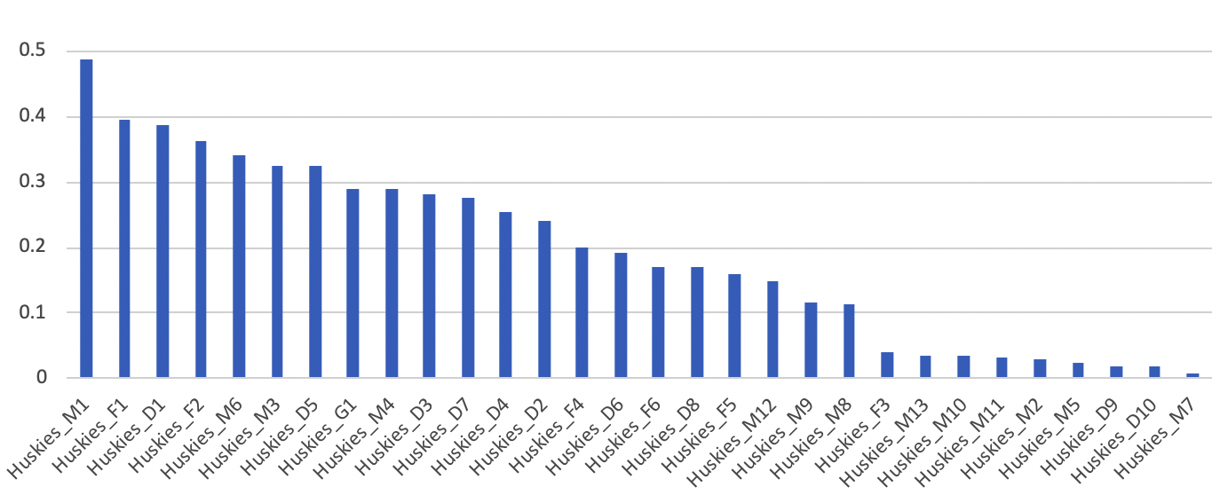

Figure 15 Players’ average contribution

Similarly, we analyze the players’ contribution in each match. The max contribution is around 0.7202, the mean contribution is around 0.1921 and the standard deviation is around 0.2425. The max contribution is less than mean contribution plus three times standard deviation, which means that the distribution of contribution is reasonable that there are one or more players play a key role but not a role that is almost equivalent to a whole team.

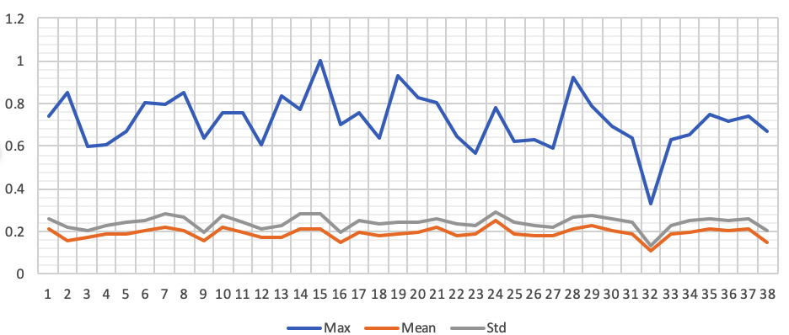

Figure 16 Players’ contribution in each match

* 1. **HUSKIES’ ATTACK-DEFENSE STRATEGY AND PEZZALI SCORE**

We analyze Huskies’ attack-defense strategy by plot the distribution of the players’ location in each event of a match. Here we take the 2nd, 10th, 18th and 26th match for example. In the 2nd and 18th match, the defense of Huskies blocked most of the attack from the opponent, while a few of the attempt of Huskies’ forward to attack on the left side was also hindered. We think they adopted a strategy to put priority on defense. However, in the 10th and 26th match, Huskies’ players were more interested in dueling and passing the ball in front of the goal of opponent when attacking and few players were left in front of the goal to prevent the opponent from attacking. We think they put a stress on attacking this time. Similarly, we analyzed all strategies of Huskies in 38 matches.

As analyzed above, the Huskies has more advantage in defense than attack. When Huskies performs well in defense, at worst they will receive a result of a tie. However, when Huskies pay more attention to attack and little attention to defense, they are not easy to win. For example, the result of the 2nd match and the 18th match are tie and win, while that of the 10th and 26th match are loss.

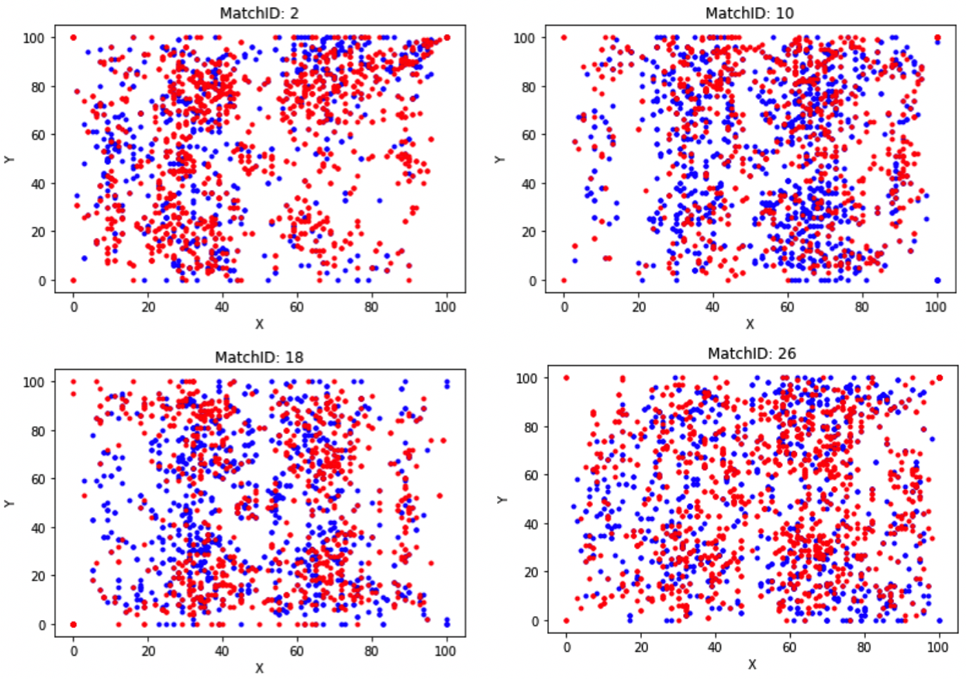

Figure 17 Distribution of players’ location

As mentioned by Paolo Cintia, et al. (2015), we compute the Pezzali score of Huskies to describe the efficiency in both attack and defense according to the following formula,

$$PezzaliScore\left(team\right)=\frac{\left|goals\left(team\right)\right|}{\left|attempts\left(team\right)\right|}×\frac{\left|attempts\left(opponent\right)\right|}{\left|goals\left(opponent\right)\right|}$$

where $\left|attempts\left(team\right)\right|$ equals to times of a team shooting. Considering that in some cases opponents scores 0 in the end, we standardize the four values on the right side of the formula.

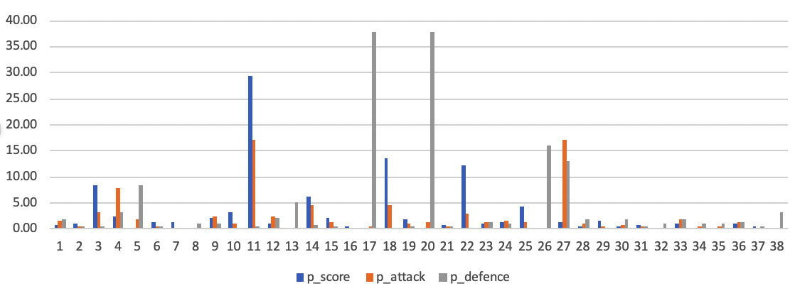

Figure 18 Distribution of players’ location

Inspired by Paolo Cintia, et al. (2015), We create two indicators to measure the efficiency of attack and the efficiency of defense according to the following formula [1],

The Pezzali score, attack score and defense score are shown in the figure above. It is worth mention that the Pezzali score, attack score and defense score are the measure of efficiency in attack and defense, which illustrate how well the teamwork is going on but not the results of matches although there may exist some kind of relationship between teamwork and result of the match.

* 1. **SUBSTITUTION STRATEGY AND ITS EFFECT**

We find that Huskies have three times of substitution in the second half of every match. Substitution can be out of some kinds of strategies. For example, a team do well in defense in the first half of the game, and they substitute for players with better ability in attack to win the game when opponents are exhausted. We put different weight on different kinds of substitution.

Table 7 Weight of different kinds of substitution

|  |  |
| --- | --- |
| weight | substitution |
| -2 | forward $→$ defense |
| -1 | forward $→$ midfield, midfield $→$ defense |
| 1 | defense $→$ midfield, midfield $→$ forward |
| 2 | defense $→$ forward |

The positive weight means the team substitute for players with better attack and the absolute value of the weight is the degree of paying more attention in attack or defense. We sum up the weight of three substitution in one match and get the value of the indicator.

Table 8 Substitution strategies

|  |  |  |
| --- | --- | --- |
| weight | Match ID | count |
| -3 | 16 | 1 |
| -2 | 14, 15, 17, 25, 32, 34, 36 | 7 |
| -1 | 1, 22, 30, 31 | 4 |
| 0 | 2, 4, 6, 9, 10, 11, 18, 19, 20, 23, 27, 28, 33 | 13 |
| 1 | 3, 5, 7, 8, 13, 21, 24, 26, 29, 35, 37, 38 | 12 |
| 2 | 12 | 1 |

From the table above, we can see that most time Huskies adopt a slightly aggressive or neutral substitution strategy. However, Huskies won the games but for the 22nd and 32nd match when adopting a conservative strategy. We consider that Huskies will adopt a conservative strategy when find they are likely to win without accident but adopt an aggressive strategy when find they are likely to lose the game without accident.

* 1. **DUEL RATE**

In this part, we use duel rate to measure the rate of the players to ‘win’ duel in a single match. We assume that more skillful player will get the football more times. Thus, if two teams with approximately skillful players, the duel rate of each team will be around 0.5, or close to.

From the data, we can find duel events always occurs with a series record happened in the next few seconds. We define such an event as one duel series and the origin player of the first event possess the ball at first. If origin player of the last event in the series is not the same team as the first one, we define they ‘lose’ the duel series. We calculate the rate of every team lose duel and denote it as duel rate.

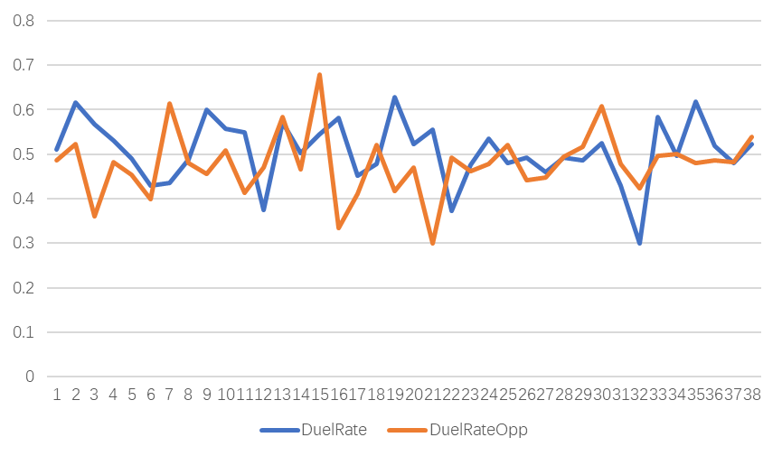

Figure 19 Duel rate in every match

We can easily find that the blue line always above the orange line, which means the Huskies lose much more duels than their opponents. How to possess the ball in duel is also significant to the result. The more times win the duel, the more initiative the team have.

* 1. **MODELS CAPTURING THE FEATURES OF THE TEAMWORK**

We put together all the indicators mentioned above and use machine learning methods to construct models capturing features of teamwork. Considering that there is no value recording teamwork directly and better teamwork usually lead to better result of the game, we take the results of matches as the labels of machine learning models. Win, tie and loss are represented by 2, 1 and 0 respectively.

We use XGBoost to select some important features from all the features concerning 38 matches, and the graph below shows the importance of features. We select features ranked top 40% in importance (14 features in total) and use Principal component analysis (PCA) to reduce the dimension of the data. The cumulative variance contribution rate of the first two principal components is 0.9960.



Figure 20 Importance of top 15 features

We divide 70% of the data into training dataset, and the left into testing dataset. We try several different models including XGBoost, K-Nearest Neighbor (KNN), Support Vector Machine (SVM), Stochastic Gradient Descent (SGD) and so on. The accuracy of fitting and prediction of different models are shown as below.

Table 9 Accuracy of fitting and prediction of different models

|  |  |  |
| --- | --- | --- |
| Model | Fitting | Prediction |
| KNN | ﻿1.0000 | ﻿0.4167 |
| SGD | ﻿0.3846 | ﻿0.5833 |
| SVM | ﻿1.0000 | ﻿0.5833 |
| XGBoost | 0.9615 | 0.7500 |

We find that XGBoost has the best accuracy in prediction of and a satisfying accuracy in fitting. Considering there is no significant difference between the accuracy of fitting and prediction, we think the overfitting problem is not of much influence though there are total 38 items in our data.

In conclusion, with the 14 features of a game and XGBoost model, we can illustrate the performance of a team with regard to teamwork and predict the result of the match at an accuracy of around 0.75.

1. **ADVICES FOR HUSKIES**
   1. **VIEWS ON PLAYERS**

In the first part, we discuss about collaborations among players in Huskies. Some players play more important roles in the team. Midfield players are indispensable to transfer the ball from backcourt to frontcourt. Especially, Player M1 takes part in most of the dyadic and triadic collaborations. It’s fortunate for Huskies to own such an excellent player. However, other players do not seem to have the same contribution as M1. If M1 one day gets injured or left the team, the team will lose engine and hub in the game. Depending on single well-behaved player is bad for Huskies long run development. Coaches should also pay attention to cultivate those potential players and enhance diversified passing routes.

Another existed problem is the players’ position. Too many players are in the center of midfield which leads to lack of catching spots on left and right wings. Besides, there are defenders active on two midfield wings in Huskies formation. Generally, wingers should take the ball to break through opponent’s offense, however, defenders are in disadvantages in speed and breakthrough techniques. Therefore, midfield players are needed to be trained to adapt different positions and relieve defenders’ pressure.

We select two highest-scoring matches to compare players’ behaviors. In match 14th, Huskies wins with 4 goals and loses by 2 to 5 in match 9th. The figure21(a) represents a strong passing awareness among Huskies. Edges’ width is apparently wider than figure21(b). It does prove that more passes lead to better performance to some extent. In figure21(b), there is only one forward F1 going close to opponent’s goal. However, F1 do not establish strong connection with midfield players. Then comes to the positions, in figure21(a), players stand separately. But in figure21(b), many players’ positions are overlapping which results in defense vacancy. When all the team members like figure21(a) contribute to the team averagely, Huskies can behave at its best.

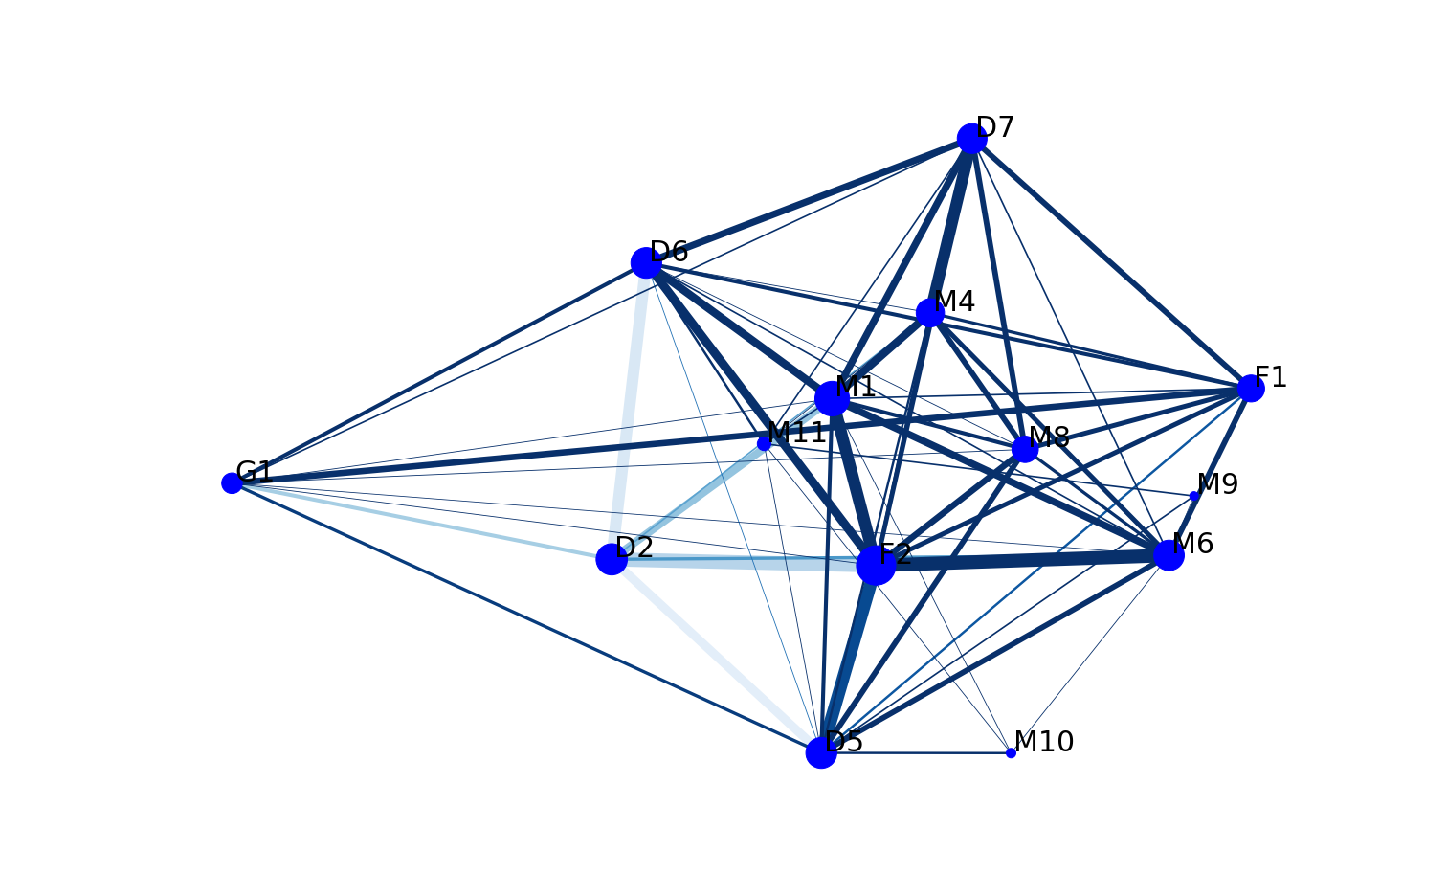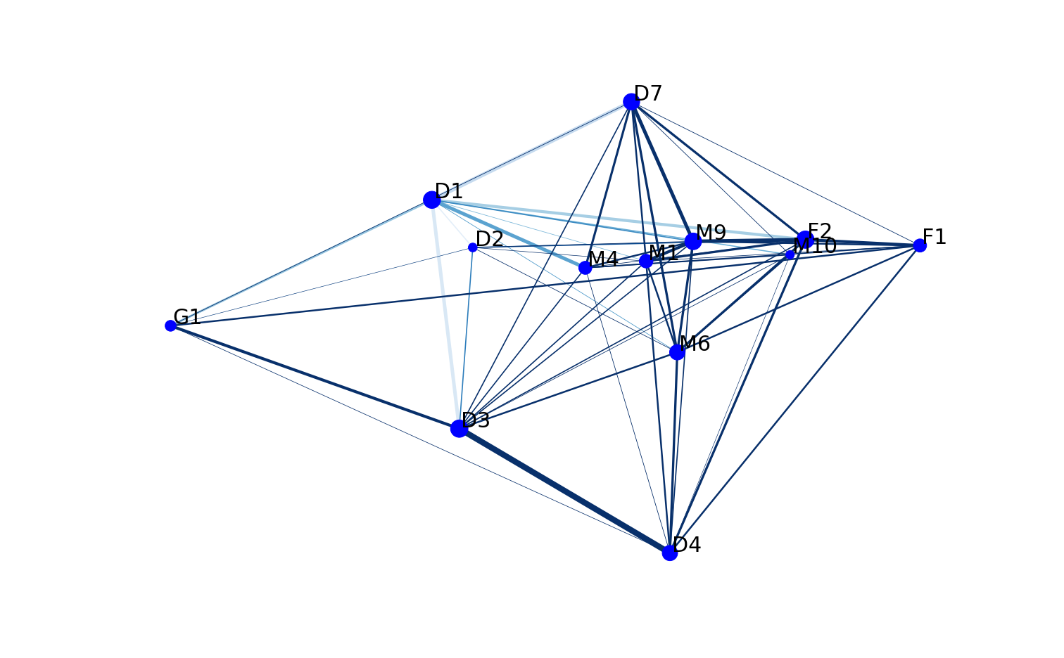

Figure 21 Single match formation: (a) Match 14th, Huskies4:0 win; (b) Match 9th, Huskies2:5 loss

To sum up, from the perspective of players, the players and coaches should realize that key players can’t lead the team to win. All players are required to perform their own functions.

* 1. **VIEWS ON THE TEAM STRATEGY**

From the features’ importance, we can know what is important to predict the result of the match, so that we can recommend the effective strategy specially to Huskies. In the top 40% important features, there are features concerning the opponents, which we cannot change it easily or we can only get over it by specific strategy to the opponent. Beside these, other features are what is important for Huskies to improve during next season.

In these features, the most important one is the average passing events in different location $μ_{L}$. It is not difficult to understand that the more passing events in every parts of the court, the more initiative they are, and the more possible they can goal and gain score. And, the total passing volume $ω$ and average passing events of players $μ_{P}$ are both important. But still, this is not the eventual strategy they can improve. From other features, we can see several parts.

First, we can see the dribble is important both in the distance and duration, which is the basic ability for a football player. The longer the football towards to the opponent’s goal, the more shot events occur, and more scores gained.

Second, the duel rate is also important, as well as fail to catch ball ratio. These two rates reflect the rate of the fault of the team, which is vital to improve the team’s performance. Decreasing the fault in the match means decreasing the possible losing the ball. Thus, the lower score the opponents will gain, and the more possible Huskies will win.

Third, the average contribution of players. We know that football is a team competition and a single player without teammates’ cooperation cannot make difference to the result. Thus, balancing all players’ contribution plays an important part to the success. Although it is not so easy to complete, the significance of this is what we need to clarify.

1. **KEY INDICATORS TO IMPROVE TEAM’S PERFORMANCE**
   1. **TEAMWORK**

Literally speaking, teamwork teams every member in the team must contribute to the collective. Key members in the team can greatly improve team’s performance. However, they are not universal. Depending on these key members only and ignoring cultivating others will do harm to the team’s long-run development. As the old saying goes, “two heads are better than one”, paying equal attention to all the team members is of great benefit to the team performance.

* 1. **PERFORM THEIR DUTIES**

Everyone has their own specialty. As team members, we all should adopt our good points and avoid the shortcoming. Just like the football team, defenders are responsible for defense and forwards seize the chance to attack. To maximize team’s value, every member should only focus on own work instead of fighting for those fancy jobs.

* 1. **PLAY BY EAR**

In previous part, we put forward the point that people should focus owe work. Does it mean that team members should behave conservatively? The answer is absolutely no. Play by ear means that the team strategy has to be changeable to adapt different situations. In a football match, when a defender carries the ball going deep into opponent’s field, other players should take his place instead of standstill in case of fight back.

* 1. **FURTHER EVALUTATION MEAN**

In Huskies’ case, we analyze the teamwork by their outer behavior like passes, shot etc. Another important indicator to estimate the team performance is individual information and character. Football players differ in height, weight, foot ability. The factors partly decide members’ role in a team. Therefore, considering all these inner and outer circumstances can we better have a comprehensive evaluation on the team.

* 1. **WEAKNESS OF THE TEAM**

In the analysis above, we consider the fault both on individual and team level, such as fail to catch ball ratio and duel rate. Recognizing the team’s weakness is also important, which not only we can use special strategy, but also is the direction to improve in the future.

**REFERENCE**

[1] Cintia P, Pappalardo L, Pedreschi D, et al. The harsh rule of the goals: Data-driven performance indicators for football teams[C]// 2015 IEEE International Conference on Data Science and Advanced Analytics (DSAA'15). IEEE, 2015.

**APPENDIX——CODE (BASE ON PYTHON3)**

**TEAM FORMATION ANALYSIS**

#!/usr/bin/env python

# coding: utf-8

**import** re

**import** numpy **as** np

**import** pandas **as** pd

**import** matplotlib**.**pyplot **as** plt

**import** networkx **as** nx

path **=** 'D:/MCM/'

address_csv **=** 'passingevents.csv'

#%%

df**=**pd**.**read_csv**(**path**+**address_csv**)**

df**.**columns

#%%

player_ori_huskies**=**df**[**df**[**"TeamID"**]==**'Huskies'**].**iloc**[:,**2**]** # ori为Huskies出球队员

player_des_huskies**=**df**[**df**[**"TeamID"**]==**'Huskies'**].**iloc**[:,**3**]** # des为HusKies接球队员

player_ori_huskies**=list(**player_ori_huskies**.**unique**())**

player_des_huskies**=list(**player_des_huskies**.**unique**())**

player_ori_huskies**.**sort**()**

player_des_huskies**.**sort**()**

dis_ori_x**=list(**df**[**"EventOrigin_x"**])**

dis_ori_y**=list(**df**[**"EventOrigin_y"**])**

dis_des_x**=list(**df**[**"EventDestination_x"**])**

dis_des_y**=list(**df**[**"EventDestination_y"**])**

distance**=[]**

**for** i **in** **range(len(**dis_des_y**)):**

distance**.**append**(((**dis_ori_x**[**i**]-**dis_des_x**[**i**])\*\***2**+(**dis_des_y**[**i**]-**dis_ori_y**[**i**])\*\***2**)\*\***0.5**)**

distance**[**i**]=int(**distance**[**i**]/**3**)**

# print(distance[0:5])

player_huskies **=** player_ori_huskies # 出球与接球队员相同，归结为参与的队员

weight**=[**0.780373832**,**0.81795196**,**0.812659847**,**0.832448093**,**0.842606707**,**0.841178878**,**0.83362069**,**

0.849388753**,**0.835820896**,**0.836218375**,**0.842622951**,**0.84305835**,**0.812176166**,**0.829679595**,**

0.806215722**,**0.705202312**,**0.773413897**,**0.746212121**,**0.79342723**,**0.720430108**,**0.645833333**,**

0.714285714**,**0.721518987**,**0.639344262**,**0.818181818**,**0.846153846**,**0.9375**,**0.875**,**0.8**,**0.8**,**0.8**,**

0.8**,**0.8**,**0.8**,**0.8**,**0.8**,**0.8**,**0.8**,**0.8**,**0.8**,**0.8**,**0.8**,**0.8**,**0.8**,**0.8**,**0.8**]**

# %%

pairs_distinct**=[]**

**for** i **in** **range(len(**player_ori_huskies**)-**1**):**

**for** j **in** **range(**i**+**1**,len(**player_ori_huskies**)):**

pairs_distinct**.**append**([**player_ori_huskies**[**i**],**player_ori_huskies**[**j**]])**

# df["pairs"]='['+df.iloc[:,2].map(str)+','+df.iloc[:,3].map(str)+']'

ori_player**=**df**.**iloc**[:,**2**].**tolist**()**

des_player**=**df**.**iloc**[:,**3**].**tolist**()**

# pairs=df.iloc[:,11]

pairs**=[]**

**for** i **in** **range(len(**ori_player**)):**

**if(**ori_player**[**i**]<=**des_player**[**i**]):**

pairs**.**append**([**ori_player**[**i**],**des_player**[**i**]])**

**if(**ori_player**[**i**]>**des_player**[**i**]):**

pairs**.**append**([**des_player**[**i**],**ori_player**[**i**]])**

# print(pairs_distinct[1])

count_link**=[]**

pairs_each**=[]**

k**=**0

**for** i **in** **range(**435**):**

count_link**.**append**(**0**)**

# print(len(pairs_distinct))

**for** i **in** **range(len(**pairs**)):**

pairs_each**.**append**(**pairs**[**i**])**

**for** i **in** pairs_distinct**:**

**for** j **in** **range(len(**pairs_each**)):**

**if** pairs_each**[**j**]==**i**:**

count_link**[**k**]=**count_link**[**k**]+**weight**[**distance**[**j**]]**

k**=**k**+**1

# 按pairs里面的顺序每组关系计数

pairs_distinct_1**=[]**

**for** i **in** **range(len(**player_ori_huskies**)-**1**):**

**for** j **in** **range(**i**+**1**,len(**player_ori_huskies**)):**

pairs_distinct_1**.**append**([**player_ori_huskies**[**i**],**player_ori_huskies**[**j**]])**

**for** k **in** **range(len(**pairs_distinct_1**)):**

pairs_distinct_1**[**k**].**append**(**count_link**[**k**])**

# print(pairs_distinct_1[0:5])

#%%

# 求每一个球员传球位置均值

player_ori_arr **=** **[]**

player_des_arr **=** **[]**

player_x **=** **[]**

player_y **=** **[]**

pos_player_mean **=** **{}**

**for** i **in** player_huskies**:**

_df1 **=** df**[**df**[**'OriginPlayerID'**]==**i**]**

_df2 **=** df**[**df**[**'DestinationPlayerID'**]==**i**]**

player_ori_arr**.**append**(**_df1**)**

player_des_arr**.**append**(**_df2**)**

_x1 **=** **list(**_df1**[**'EventOrigin_x'**])**

_x2 **=** **list(**_df2**[**'EventDestination_x'**])**

_x **=** _x1**+**_x2

_mean_x **=** np**.sum(**_x**)/**np**.**size**(**_x**)**

_y1 **=** **list(**_df1**[**'EventOrigin_y'**])**

_y2 **=** **list(**_df2**[**'EventDestination_y'**])**

_y **=** _y1**+**_y2

_mean_y **=** np**.sum(**_y**)/**np**.**size**(**_y**)/**105**\***65

player_x**.**append**(**_mean_x**)**

player_y**.**append**(**_mean_y**)**

_l **=** **[**_mean_x**,** _mean_y**]**

pos_player_mean**[**i**]** **=** _l

df**.**columns

#%%

#计算H值

Hus_data **=** df**.**loc**[**df**[**'TeamID'**]** **==** 'Huskies'**]**

groupOri **=** Hus_data**.**groupby**([**'MatchID'**,**'OriginPlayerID'**]).**count**()**

groupDes **=** Hus_data**.**groupby**([**'MatchID'**,**'DestinationPlayerID'**]).**count**()**

groupOri **=** pd**.**DataFrame**(**groupOri**,** columns**=[**'TeamID'**])**

groupDes **=** pd**.**DataFrame**(**groupDes**,** columns**=[**'TeamID'**])**

groupOri**.**rename**(**columns**={**'TeamID'**:**'count1'**},**inplace**=True)**

groupDes**.**rename**(**columns**={**'TeamID'**:**'count2'**},**inplace**=True)**

sumCount **=** pd**.**concat**([**groupOri**,**groupDes**],**axis**=**1**)**

sumCount**.**fillna**(**0**,**inplace**=True)**

sumCount**[**'count'**]** **=** sumCount**[**'count1'**]** **+** sumCount**[**'count2'**]**

index **=** sumCount**.**index**.**to_frame**()**

sumCount **=** pd**.**concat**([**sumCount**[**'count'**],**index**[**0**]],**axis**=**1**)**#每场比赛每名球员传球数（传出+接受）

sumbyPlayer **=** pd**.**concat**([**sumCount**[**'count'**],**index**[**1**]],**axis**=**1**)**

PointSize **=** sumbyPlayer**.**groupby**(**1**).sum()**#每名球员所有场次传球数和

#%%

# 绘图

plt**.**figure**(**dpi**=**400**)**

plt**.**figure**(**figsize**=[**21**,**13**])**

G**=**nx**.**Graph**()**

G**.**add_nodes_from**(**player_ori_huskies**)**#添加点a

G**.**add_weighted_edges_from**(**pairs_distinct_1**)**

node_sizes **=** **list(**PointSize**[**"count"**])** # 点的数量

M **=** G**.**number_of_edges**()** # 边的数量

# pos = nx.random_layout(G)

edge_colors **=** **range(**2**,** M **+** 2**)**

nodes **=** nx**.**draw_networkx_nodes**(**G**,** pos_player_mean**,** node_size**=**node_sizes**,** node_color**=**'blue'**)**

edges **=** nx**.**draw_networkx_edges**(**G**,** pos_player_mean**,** node_size**=**node_sizes**,** arrowstyle**=**'->'**,**

arrowsize**=**10**,** edge_color**=**edge_colors**,**

edge_cmap**=**plt**.**cm**.**Blues**,**

edge_vmin**=**0**,**edge_vmax**=**450**,**width**=[float(**v**[**'weight'**]/**7**)** **for** **(**r**,**c**,**v**)** **in** G**.**edges**(**data**=True)])**

**for** i **in** **range(len(**player_huskies**)):**

_player **=** player_huskies**[**i**]**

_x**,** _y **=** pos_player_mean**[**_player**]**

plt**.**text**(**_x**+**0.12**,** _y**+**0.12**,** _player**[**8**:],** size **=** 30**,** alpha **=** 1**)**

ax **=** plt**.**gca**()**

ax**.**set_axis_off**()** # 取消图的边框

plt**.**savefig**(**path**+**'test_total.png'**)**

plt**.**show**()**

**HEATMAP**

_df1 **=** df**[**df**[**'TeamID'**]==**'Huskies'**]**

_df2 **=** df**[**df**[**'TeamID'**]==**'Huskies'**]**

_x1 **=** **list(**_df1**[**'EventOrigin_x'**])**

_x2 **=** **list(**_df2**[**'EventDestination_x'**])**

_y1 **=** **list(**_df1**[**'EventOrigin_y'**])**

_y2 **=** **list(**_df2**[**'EventDestination_y'**])**

point**=[]**

__x1**=[]**

__x2**=[]**

__y1**=[]**

__y2**=[]**

size**=**20

**for** i **in** **range(len(**_x1**)):**

__x1**.**append**(**size**\***_x1**[**i**])**

__x2**.**append**(**size**\***_x2**[**i**])**

__y1**.**append**(int(**size**\***_y1**[**i**]\***68**/**105**))**

__y2**.**append**(int(**size**\***_y2**[**i**]\***68**/**105**))**

**for** i **in** **range(len(**_x1**)):**

point**.**append**([**__x1**[**i**],**__y1**[**i**]])**

point**.**append**([**__x2**[**i**],**__y2**[**i**]])**

**print(**__x1**[**0**:**2**])**

**import** matplotlib**.**pyplot **as** plt

**from** pyheatmap**.**heatmap **import** HeatMap

plt**.**figure**(**dpi**=**200**)**

# # download test data

# data = []

# lines = open("test_data.txt").read().split("\n")

# for ln in lines:

# a = ln.split(",")

# if len(a) != 2:

# continue

# a = [int(i) for i in a]

# data.append(a)

# print(point)

# start painting

hm **=** HeatMap**(**point**)**

hm**.**heatmap**(**save_as**=**"D://MCM//heat.png"**,**r**=**50**,)**

plt**.**show**()**

**DYADIC CONFIGURATIONS**

pairs_distinct_di**=[]**

**for** i **in** **range(len(**player_ori_huskies**)):**

**for** j **in** **range(len(**player_ori_huskies**)):**

**if(**i**!=**j**):**

pairs_distinct_di**.**append**([**player_ori_huskies**[**i**],**player_ori_huskies**[**j**]])**

ori_player**=**df**.**iloc**[:,**2**].**tolist**()**

des_player**=**df**.**iloc**[:,**3**].**tolist**()**

pairs**=[]**

**for** i **in** **range(len(**ori_player**)):**

pairs**.**append**([**ori_player**[**i**],**des_player**[**i**]])**

# print(pairs_distinct[1])

count_link_di**=[]**

pairs_each**=[]**

k**=**0

**for** i **in** **range(len(**pairs_distinct_di**)):**

count_link_di**.**append**(**0**)**

**for** i **in** **range(len(**pairs**)):**

pairs_each**.**append**(**pairs**[**i**])**

**for** i **in** pairs_distinct_di**:**

**for** j **in** **range(len(**pairs_each**)):**

**if** pairs_each**[**j**]==**i**:**

count_link_di**[**k**]=**count_link_di**[**k**]+**weight**[**distance**[**j**]]**

k**=**k**+**1

# count_link.append(pairs_each.count(i))

# 按pairs里面的顺序每组关系计数

pairs_distinct_di_1**=[]**

**for** i **in** **range(len(**player_ori_huskies**)):**

**for** j **in** **range(len(**player_ori_huskies**)):**

**if(**i**!=**j**):**

pairs_distinct_di_1**.**append**([**player_ori_huskies**[**i**],**player_ori_huskies**[**j**]])**

**for** k **in** **range(len(**pairs_distinct_di_1**)):**

pairs_distinct_di_1**[**k**].**append**(**count_link_di**[**k**])**

adjacency**=**pairs_distinct_di_1

test**=**pd**.**DataFrame**(**data**=**adjacency**)**

top_node**=**16

arr_double_edge**=**np**.**array**(**test**)**

# print(arr_double_edge)

data**=**arr_double_edge

idex**=**np**.**lexsort**([-**1**\***data**[:,**2**]])**

sorted_data **=** data**[**idex**,** **:]**

arr_double_edge**=**sorted_data**.**tolist**()**

arr_double**=**arr_double_edge

arr_double_edge**=**arr_double**[**0**:**top_node**]**

inlist_double_weight**=[]**

**for** i **in** arr_double_edge**:**

inlist_double_weight**.**append**([**i**[**0**],**i**[**1**],**i**[**2**]])**

**for** i **in** **range(**top_node**):**

arr_double_edge**[**i**].**append**(**'#'**+str(**i**+**1**))**

# print(arr_double_edge)

inlist_double_name**=[]**

**for** i **in** arr_double_edge**:**

**for** j **in** **range(**2**):**

inlist_double_name**.**append**(**i**[**j**])**

# print(inlist_double_weight)

inlist_double_name**=list(set(**inlist_double_name**))**

inlist_double_name**.**sort**()**

inlist_double_link**=[]**

**for** i **in** **range(len(**inlist_double_name**)):**

inlist_double_link**.**append**(**''**)**

**for** j **in** **range(len(**arr_double_edge**)):**

**if(**inlist_double_name**[**i**]** **in** arr_double_edge**[**j**]):**

inlist_double_link**[**i**]=**inlist_double_link**[**i**]+**arr_double_edge**[**j**][**3**]**

# print(inlist_double_link)

player_ori_arr **=** **[]**

player_des_arr **=** **[]**

player_x **=** **[]**

player_y **=** **[]**

pos_player_mean **=** **{}**

**for** i **in** inlist_double_name**:**

_df1 **=** df**[**df**[**'OriginPlayerID'**]==**i**]**

_df2 **=** df**[**df**[**'DestinationPlayerID'**]==**i**]**

player_ori_arr**.**append**(**_df1**)**

player_des_arr**.**append**(**_df2**)**

_x1 **=** **list(**_df1**[**'EventOrigin_x'**])**

_x2 **=** **list(**_df2**[**'EventDestination_x'**])**

_x **=** _x1**+**_x2

_mean_x **=** np**.sum(**_x**)/**np**.**size**(**_x**)**

_y1 **=** **list(**_df1**[**'EventOrigin_y'**])**

_y2 **=** **list(**_df2**[**'EventDestination_y'**])**

_y **=** _y1**+**_y2

_mean_y **=** np**.sum(**_y**)/**np**.**size**(**_y**)/**105**\***65

player_x**.**append**(**_mean_x**)**

player_y**.**append**(**_mean_y**)**

_l **=** **[**_mean_x**,** _mean_y**]**

pos_player_mean**[**i**]** **=** _l

plt**.**figure**(**dpi**=**400**)**

plt**.**figure**(**figsize**=[**21**,**13**])**

DG**=**nx**.**MultiDiGraph**()**

DG**.**add_nodes_from**(**inlist_double_name**)**#添加点a

DG**.**add_weighted_edges_from**(**inlist_double_weight**)**

nodesizes**=[]**

**for** i **in** inlist_double_name**:**

nodesizes**.**append**(int(**PointSize**.**loc**[**i**]))**

M **=** DG**.**number_of_edges**()** # 边的数量

# pos = nx.random_layout(G)

edge_colors **=** **range(**2**,** M **+** 2**)**

nodes **=** nx**.**draw_networkx_nodes**(**DG**,** pos_player_mean**,** node_size**=**nodesizes**,** node_color**=**'blue'**)**

edges **=** nx**.**draw_networkx_edges**(**DG**,** pos_player_mean**,** node_size**=**nodesizes**,** arrowstyle**=**'->'**,**

arrowsize**=**40**,** edge_color**=**edge_colors**,**

edge_cmap**=**plt**.**cm**.**Blues**,**

edge_vmin**=**0**,**edge_vmax**=**8**,**width**=[float(**v**[**'weight'**]/**10**)** **for** **(**r**,**c**,**v**)** **in** DG**.**edges**(**data**=True)])**

# print(width_sort)

**for** i **in** **range(len(**inlist_double_name**)):**

_player **=** inlist_double_name**[**i**]**

_x**,** _y **=** pos_player_mean**[**_player**]**

plt**.**text**(**_x**+**0.14**,** _y**+**0.15**,** _player**[**8**:]+**inlist_double_link**[**i**],** size **=** 30**,** alpha **=** 2**)**

ax **=** plt**.**gca**()**

ax**.**set_axis_off**()** # 取消图的边框

plt**.**savefig**(**path**+**'test_double.png'**)**

plt**.**show**()**

**TRIADIC CONFIGURATION**

top_node_tri**=**8

adjacency_3**=**pairs_distinct_di_1

# for n, nbrs in G.adjacency():

# for nbr, eattr in nbrs.items():

# data = eattr['weight']

# adjacency_3.append([n,nbr,data])

three_adj**=[]**

**for** i **in** **range(len(**adjacency**)-**1**):**

**for** j **in** **range(**i**+**1**,len(**adjacency**)):**

**if(len(list(set(**adjacency**[**i**][**0**:**2**]+**adjacency**[**j**][**0**:**2**])))==**3 **and** adjacency**[**i**][**1**]==**adjacency**[**j**][**0**]):**

three_adj**.**append**([**adjacency**[**i**][**0**],**adjacency**[**i**][**1**],**adjacency**[**i**][**2**],**adjacency**[**j**][**0**],**adjacency**[**j**][**1**],**adjacency**[**j**][**2**],**adjacency**[**i**][**2**]+**adjacency**[**j**][**2**]])**

# print(three_adj[0:20])

test_3**=**pd**.**DataFrame**(**data**=**three_adj**)**

arr_tri_edge**=[]**

arr_tri_edge**=**np**.**array**(**test_3**)**

data_3**=**arr_tri_edge

idex_3**=**np**.**lexsort**([-**1**\***data_3**[:,**6**]])**

sorted_data_3 **=** data_3**[**idex_3**,** **:]**

arr_tri_edge**=**sorted_data_3**.**tolist**()**

# arr_tri=arr_tri_edge[0::36]

arr_tri_edge**=**arr_tri_edge**[**0**:**top_node_tri**]**

**for** i **in** **range(**top_node_tri**):**

arr_tri_edge**[**i**].**append**(**'#'**+str(**i**+**1**))**

inlist_tri_name**=[]**

inlist_tri_weight**=[]**

**for** i **in** arr_tri_edge**:**

**for** j **in** **range(**2**):**

inlist_tri_name**.**append**(**i**[**j**])**

inlist_tri_name**.**append**(**i**[**j**+**3**])**

inlist_tri_weight**.**append**([**i**[**0**],**i**[**1**],**i**[**2**]])**

inlist_tri_weight**.**append**([**i**[**3**],**i**[**4**],**i**[**5**]])**

inlist_tri_name**=list(set(**inlist_tri_name**))**

inlist_tri_name**.**sort**()**

inlist_tri_link**=[]**

**for** i **in** **range(len(**inlist_tri_name**)):**

inlist_tri_link**.**append**(**''**)**

**for** j **in** **range(len(**arr_tri_edge**)):**

**if(**inlist_tri_name**[**i**]** **in** arr_tri_edge**[**j**]):**

inlist_tri_link**[**i**]=**inlist_tri_link**[**i**]+**arr_tri_edge**[**j**][**7**]**

player_ori_arr **=** **[]**

player_des_arr **=** **[]**

player_x **=** **[]**

player_y **=** **[]**

pos_player_mean **=** **{}**

**for** i **in** inlist_tri_name**:**

_df1 **=** df**[**df**[**'OriginPlayerID'**]==**i**]**

_df2 **=** df**[**df**[**'DestinationPlayerID'**]==**i**]**

player_ori_arr**.**append**(**_df1**)**

player_des_arr**.**append**(**_df2**)**

_x1 **=** **list(**_df1**[**'EventOrigin_x'**])**

_x2 **=** **list(**_df2**[**'EventDestination_x'**])**

_x **=** _x1**+**_x2

_mean_x **=** np**.sum(**_x**)/**np**.**size**(**_x**)**

_y1 **=** **list(**_df1**[**'EventOrigin_y'**])**

_y2 **=** **list(**_df2**[**'EventDestination_y'**])**

_y **=** _y1**+**_y2

_mean_y **=** np**.sum(**_y**)/**np**.**size**(**_y**)/**105**\***65

player_x**.**append**(**_mean_x**)**

player_y**.**append**(**_mean_y**)**

_l **=** **[**_mean_x**,** _mean_y**]**

pos_player_mean**[**i**]** **=** _l

plt**.**figure**(**dpi**=**400**)**

plt**.**figure**(**figsize**=[**21**,**13**])**

TG**=**nx**.**MultiDiGraph**()**

TG**.**add_nodes_from**(**inlist_tri_name**)**#添加点a

TG**.**add_weighted_edges_from**(**inlist_tri_weight**)**

# print(inlist_tri_weight)

nodesizes**=[]**

**for** i **in** inlist_tri_name**:**

nodesizes**.**append**(int(**PointSize**.**loc**[**i**]))**

M **=** TG**.**number_of_edges**()** # 边的数量

edge_colors **=** **range(**2**,** M **+** 2**)**

# width_sort=[]

# for (r,c,v) in G.edges(data=True):

# width_sort.append(v['weight'])

# width_sort.sort(reverse=True)

# edge=0

# for (r,c,v) in TG.edges(data=True):

# edge=edge+1

# width_min=min(width_sort[0:edge])

# for i in range(edge):

# width_sort[i]=width_sort[i]/width_min*5

nodes **=** nx**.**draw_networkx_nodes**(**TG**,** pos_player_mean**,** node_size**=**nodesizes**,** node_color**=**'blue'**)**

edges **=** nx**.**draw_networkx_edges**(**TG**,** pos_player_mean**,** node_size**=**nodesizes**,** arrowstyle**=**'->'**,**

arrowsize**=**20**,** edge_color**=**edge_colors**,**

edge_cmap**=**plt**.**cm**.**Blues**,**

edge_vmin**=**0**,**edge_vmax**=**5**,**width**=[float(**v**[**'weight'**]/**10**)** **for** **(**r**,**c**,**v**)** **in** TG**.**edges**(**data**=True)])**

**for** i **in** **range(len(**inlist_tri_name**)):**

_player **=** inlist_tri_name**[**i**]**

_x**,** _y **=** pos_player_mean**[**_player**]**

plt**.**text**(**_x**+**0.14**,** _y**+**0.15**,** _player**[**8**:]+**inlist_tri_link**[**i**],** size **=** 30**,** alpha **=** 2**)**

ax **=** plt**.**gca**()**

ax**.**set_axis_off**()** # 取消图的边框

plt**.**savefig**(**path**+**'test_tri.png'**)**

plt**.**show**()**

**print(**inlist_tri_weight**)**

**EACH MATCH FORMATION**

matchid**=**38

df_matchid**=**df**[**df**[**'MatchID'**]==**matchid**]**

df_team**=**df_matchid**[**df_matchid**[**'TeamID'**]==**'Huskies'**]**

player_huskies_matchid**=**df_team**[**"OriginPlayerID"**].**unique**()**

player_huskies_matchid**=**player_huskies_matchid**.**tolist**()**

player_huskies_matchid**.**sort**()**

# print(player_huskies_matchid)

pairs_distinct_matchid**=[]**

**for** i **in** **range(len(**player_huskies_matchid**)-**1**):**

**for** j **in** **range(**i**+**1**,len(**player_huskies_matchid**)):**

pairs_distinct_matchid**.**append**([**player_huskies_matchid**[**i**],**player_huskies_matchid**[**j**]])**

ori_player_matchid**=**df_matchid**.**iloc**[:,**2**].**tolist**()**

des_player_matchid**=**df_matchid**.**iloc**[:,**3**].**tolist**()**

pairs_matchid**=[]**

**for** i **in** **range(len(**ori_player_matchid**)):**

**if(**ori_player_matchid**[**i**]<=**des_player_matchid**[**i**]):**

pairs_matchid**.**append**([**ori_player_matchid**[**i**],**des_player_matchid**[**i**]])**

**if(**ori_player_matchid**[**i**]>**des_player_matchid**[**i**]):**

pairs_matchid**.**append**([**des_player_matchid**[**i**],**ori_player_matchid**[**i**]])**

# print(pairs_distinct[1])

count_link_matchid**=[]**

pairs_each_matchid**=[]**

k**=**0

**for** i **in** **range(len(**pairs_distinct_matchid**)):**

count_link_matchid**.**append**(**0**)**

# print(len(pairs_distinct))

**for** i **in** **range(len(**pairs_matchid**)):**

pairs_each_matchid**.**append**(**pairs_matchid**[**i**])**

**for** i **in** pairs_distinct_matchid**:**

**for** j **in** **range(len(**pairs_each_matchid**)):**

**if** pairs_each_matchid**[**j**]==**i**:**

count_link_matchid**[**k**]=**count_link_matchid**[**k**]+**weight**[**distance**[**j**]]**

k**=**k**+**1

# print(df)

pairs_distinct_matchid_1**=[]**

**for** i **in** **range(len(**player_huskies_matchid**)-**1**):**

**for** j **in** **range(**i**+**1**,len(**player_huskies_matchid**)):**

pairs_distinct_matchid_1**.**append**([**player_huskies_matchid**[**i**],**player_huskies_matchid**[**j**]])**

**for** k **in** **range(len(**pairs_distinct_matchid_1**)):**

pairs_distinct_matchid_1**[**k**].**append**(**count_link_matchid**[**k**])**

#%%

# 求每一个球员传球位置均值

player_ori_arr **=** **[]**

player_des_arr **=** **[]**

player_x **=** **[]**

player_y **=** **[]**

pos_player_mean_matchid **=** **{}**

**for** i **in** player_huskies_matchid**:**

_df1 **=** df_matchid**[**df_matchid**[**'OriginPlayerID'**]==**i**]**

_df2 **=** df_matchid**[**df_matchid**[**'DestinationPlayerID'**]==**i**]**

player_ori_arr**.**append**(**_df1**)**

player_des_arr**.**append**(**_df2**)**

_x1 **=** **list(**_df1**[**'EventOrigin_x'**])**

_x2 **=** **list(**_df2**[**'EventDestination_x'**])**

_x **=** _x1**+**_x2

_mean_x **=** np**.sum(**_x**)/**np**.**size**(**_x**)**

_y1 **=** **list(**_df1**[**'EventOrigin_y'**])**

_y2 **=** **list(**_df2**[**'EventDestination_y'**])**

_y **=** _y1**+**_y2

_mean_y **=** np**.sum(**_y**)/**np**.**size**(**_y**)/**105**\***65

player_x**.**append**(**_mean_x**)**

player_y**.**append**(**_mean_y**)**

_l **=** **[**_mean_x**,** _mean_y**]**

pos_player_mean_matchid**[**i**]** **=** _l

#%%

# 绘图

plt**.**figure**(**dpi**=**400**)**

plt**.**figure**(**figsize**=[**21**,**13**])**

EG**=**nx**.**Graph**()**

EG**.**add_nodes_from**(**player_huskies_matchid**)**#添加点a

EG**.**add_weighted_edges_from**(**pairs_distinct_matchid_1**)**

# node_sizes = list(PointSize["count"]) # 点的数量

M **=** EG**.**number_of_edges**()** # 边的数量

# pos = nx.random_layout(G)

edge_colors **=** **range(**2**,** M **+** 2**)**

width_sort**=[]**

**for** **(**r**,**c**,**v**)** **in** EG**.**edges**(**data**=True):**

width_sort**.**append**(**v**[**'weight'**])**

edge**=**0

**for** **(**r**,**c**,**v**)** **in** EG**.**edges**(**data**=True):**

edge**=**edge**+**1

node_sort**=[]**

**for** i **in** **range(len(**player_huskies_matchid**)):**

node_sort**.**append**(**0**)**

**for** i **in** **range(len(**player_huskies_matchid**)):**

**for** **(**r**,**c**,**v**)** **in** EG**.**edges**(**data**=True):**

**if(**player_huskies_matchid**[**i**]==str(**r**)** **or** player_huskies_matchid**[**i**]==str(**c**)):**

node_sort**[**i**]=**node_sort**[**i**]+(**v**[**'weight'**])**

**for** i **in** **range(len(**node_sort**)):**

node_sort**[**i**]=**node_sort**[**i**]\***20

node_sizes**=**node_sort

nodes **=** nx**.**draw_networkx_nodes**(**EG**,** pos_player_mean_matchid**,** node_size**=**node_sizes**,** node_color**=**'blue'**)**

edges **=** nx**.**draw_networkx_edges**(**EG**,** pos_player_mean_matchid**,** node_size**=**node_sizes**,** arrowstyle**=**'->'**,**

arrowsize**=**10**,** edge_color**=**edge_colors**,**

edge_cmap**=**plt**.**cm**.**Blues**,**

edge_vmin**=**0**,**edge_vmax**=**20**,**width**=**width_sort**)**

**for** i **in** **range(len(**player_huskies_matchid**)):**

_player **=** player_huskies_matchid**[**i**]**

_x**,** _y **=** pos_player_mean_matchid**[**_player**]**

plt**.**text**(**_x**+**0.15**,** _y**+**0.14**,** _player**[**8**:],** size **=** 30**,** alpha **=** 1**)**

ax **=** plt**.**gca**()**

ax**.**set_axis_off**()** # 取消图的边框

plt**.**savefig**(**path**+**'test_matchid'**+str(**matchid**)+**'.png'**)**

plt**.**show**()**

**H-INDEX**

# -*- coding: utf-8 -*-

"""

Created on Sat Feb 15 11:11:13 2020

@author: 匡查理

"""

**def** Hscore**(**df**,**Team**):**

data **=** df**.**loc**[**df**[**'TeamID'**]** **==** Team**]**

groupOri **=** data**.**groupby**([**'MatchID'**,**'OriginPlayerID'**]).**count**()**

groupDes **=** data**.**groupby**([**'MatchID'**,**'DestinationPlayerID'**]).**count**()**

groupOri **=** pd**.**DataFrame**(**groupOri**,** columns**=[**'TeamID'**])**

groupDes **=** pd**.**DataFrame**(**groupDes**,** columns**=[**'TeamID'**])**

groupOri**.**rename**(**columns**={**'TeamID'**:**'count1'**},**inplace**=True)**

groupDes**.**rename**(**columns**={**'TeamID'**:**'count2'**},**inplace**=True)**

sumCount **=** pd**.**concat**([**groupOri**,**groupDes**],**axis**=**1**)**

sumCount**.**fillna**(**0**,**inplace**=True)**

sumCount**[**'count'**]** **=** sumCount**[**'count1'**]** **+** sumCount**[**'count2'**]**

index **=** sumCount**.**index**.**to_frame**(**name**=[**0**,**1**])**

sumCount **=** pd**.**concat**([**sumCount**[**'count'**],**index**[**0**]],**axis**=**1**)**#每场比赛每名球员传球数（传出+接受）

omega **=** sumCount**.**groupby**([**0**]).sum()**

omega**.**rename**(**columns**={**'count'**:**'omega'**},**inplace**=True)**

mu **=** sumCount**.**groupby**([**0**]).**mean**()**

mu**.**rename**(**columns**={**'count'**:**'mu'**},**inplace**=True)**

sigma **=** sumCount**.**groupby**([**0**]).**std**()**

sigma**.**rename**(**columns**={**'count'**:**'sigma'**},**inplace**=True)**

#划分25个区域（5*5）

data**[**'ox'**]** **=** np**.**ceil**(**data**[**'EventOrigin_x'**]/**20**)**

data**[**'oy'**]** **=** np**.**ceil**(**data**[**'EventOrigin_y'**]/**20**)**

data**[**'dx'**]** **=** np**.**ceil**(**data**[**'EventDestination_x'**]/**20**)**

data**[**'dy'**]** **=** np**.**ceil**(**data**[**'EventDestination_y'**]/**20**)**

#同理计算每场比赛每个区域传球数

groupLo **=** data**.**groupby**([**'MatchID'**,**'ox'**,**'oy'**]).**count**()**

groupLd **=** data**.**groupby**([**'MatchID'**,**'dx'**,**'dy'**]).**count**()**

groupLo **=** pd**.**DataFrame**(**groupLo**,** columns**=[**'TeamID'**])**

groupLd **=** pd**.**DataFrame**(**groupLd**,** columns**=[**'TeamID'**])**

groupLo**.**rename**(**columns**={**'TeamID'**:**'count1'**},**inplace**=True)**

groupLd**.**rename**(**columns**={**'TeamID'**:**'count2'**},**inplace**=True)**

sumCountL **=** pd**.**concat**([**groupLo**,**groupLd**],**axis**=**1**)**

sumCountL**.**fillna**(**0**,**inplace**=True)**

sumCountL**[**'count'**]** **=** sumCountL**[**'count1'**]** **+** sumCountL**[**'count2'**]**

index **=** sumCountL**.**index**.**to_frame**(**name**=[**0**,**1**,**2**])**

sumCountL **=** pd**.**concat**([**sumCountL**[**'count'**],**index**[**0**]],**axis**=**1**)**

muL **=** sumCountL**.**groupby**([**0**]).**mean**()**

muL**.**rename**(**columns**={**'count'**:**'muL'**},**inplace**=True)**

sigmaL **=** sumCountL**.**groupby**([**0**]).**std**()**

sigmaL**.**rename**(**columns**={**'count'**:**'sigmaL'**},**inplace**=True)**

#划分时间（5分钟一组，加时不算）

data**[**'T'**]** **=** np**.**ceil**(**data**[**'EventTime'**]/**300**)**

data **=** data**.**loc**[**data**[**'T'**]** **<=** 9**]**

#同理计算每场比赛每个区域传球数

groupT **=** data**.**groupby**([**'MatchID'**,**'MatchPeriod'**,**'T'**]).**count**()**

groupT **=** pd**.**DataFrame**(**groupT**,** columns**=[**'TeamID'**])**

groupT**.**rename**(**columns**={**'TeamID'**:**'count'**},**inplace**=True)**

index **=** groupT**.**index**.**to_frame**(**name**=[**0**,**1**,**2**])**

groupT **=** pd**.**concat**([**groupT**[**'count'**],**index**[**0**]],**axis**=**1**)**

muT **=** groupT**.**groupby**([**0**]).**mean**()**

muT**.**rename**(**columns**={**'count'**:**'muT'**},**inplace**=True)**

sigmaT **=** groupT**.**groupby**([**0**]).**std**()**

sigmaT**.**rename**(**columns**={**'count'**:**'sigmaT'**},**inplace**=True)**

#汇总计算H

H **=** pd**.**concat**([**omega**,**mu**,**sigma**,**muL**,**sigmaL**,**muT**,**sigmaT**],**axis**=**1**)**

H**[**'H'**]** **=** 7**/(**1**/**H**[**'omega'**]+**1**/**H**[**'mu'**]+**1**/**H**[**'sigma'**]+**1**/**H**[**'muL'**]+**1**/**H**[**'sigmaL'**]+**1**/**H**[**'muT'**]+**1**/**H**[**'sigmaT'**])**

**return** H

**def** countShot**(**df**,**Team**):**

data **=** df**.**loc**[**df**[**'TeamID'**]** **==** Team**]**

data **=** data**.**loc**[**data**[**'EventType'**]** **==** 'Shot'**]**

groupOri **=** data**.**groupby**([**'MatchID'**]).**count**()**

groupOri **=** pd**.**DataFrame**(**groupOri**,** columns**=[**'TeamID'**])**

groupOri**.**rename**(**columns**={**'TeamID'**:**'count1'**},**inplace**=True)**

**return** groupOri

**def** Duel**(**df**,**Team**):**

End **=** pd**.**concat**([**df**[**'End'**]],**axis**=**1**)**

End**.**fillna**(**method**=**'bfill'**,**inplace**=True)**

Duel **=** pd**.**concat**([**df**[**'MatchID'**],**df**[**'Begin'**],**End**[**'End'**]],**axis**=**1**)**

Duel**.**dropna**(**inplace**=True)**

data **=** Duel**.**loc**[**Duel**[**'Begin'**]** **==** Team**]**

Begin **=** data**.**groupby**([**'MatchID'**]).**count**()**

data **=** data**.**loc**[**Duel**[**'End'**]** **==** Team**]**

End **=** data**.**groupby**([**'MatchID'**,**'End'**]).**count**()**

End**.**rename**(**columns**={**'Begin'**:**'End'**},**inplace**=True)**

index **=** End**.**index**.**to_frame**(**name**=[**0**,**1**])**

End**.**index **=** index**[**0**]**

rate **=** pd**.**concat**([**Begin**[**'Begin'**],**End**[**'End'**]],**axis**=**1**)**

rate**[**'rate'**]** **=** 1**-**rate**[**'End'**]/**rate**[**'Begin'**]**#被Duel输比率

**return** rate

**import** numpy **as** np

**import** pandas **as** pd

**import** matplotlib**.**pyplot **as** plt

path **=** 'D:/大学/数学建模/大三美赛/2020_Weekend1_Problems/代码/'

address_csv **=** 'passingevents.csv'

address_csv1 **=** 'matches.csv'

address_csv2 **=** 'fullevents.csv'

#%%

passing **=** pd**.**read_csv**(**path**+**address_csv**)**

full **=** pd**.**read_csv**(**path**+**address_csv2**)**

matches **=** pd**.**read_csv**(**path**+**address_csv1**)**

#%%

#计算H值

DuelHus **=** Duel**(**full**,**'Huskies'**)**

DuelOpp **=** Duel**(**full**,**'Opponent1'**)**

**for** i **in** **range(**2**,**20**):**

Team **=** 'Opponent'**+str(**i**)**

DT **=** Duel**(**full**,**Team**)**

DuelOpp **=** pd**.**concat**([**DuelOpp**,**DT**],**axis**=**0**)**

DuelOpp**.**rename**(**columns**={**'rate'**:**'rateOpp'**},**inplace**=True)**

Duelcomp **=** pd**.**concat**([**DuelHus**[**'rate'**],**DuelOpp**[**'rateOpp'**]],**axis**=**1**)**

Duelcomp**.**reset_index**(**drop**=True,** inplace**=True)**

H **=** Hscore**(**passing**,**'Huskies'**)**

HOpp **=** Hscore**(**passing**,**'Opponent1'**)**

**for** i **in** **range(**2**,**20**):**

Team **=** 'Opponent'**+str(**i**)**

HT **=** Hscore**(**passing**,**Team**)**

HOpp **=** pd**.**concat**([**HOpp**,**HT**],**axis**=**0**)**

HOpp**.**sort_index**(**inplace**=True)**

HOpp**.**rename**(**columns**={**'H'**:**'HOpp'**},**inplace**=True)**

H**.**reset_index**(**drop**=True,** inplace**=True)**

HOpp**.**reset_index**(**drop**=True,** inplace**=True)**

HComp **=** pd**.**concat**([**H**[**'H'**],**HOpp**[**'HOpp'**],**matches**[**'Outcome'**]],**axis**=**1**)**

Htem **=** pd**.**DataFrame**(**columns**=[**'Hhome'**,** 'Haway'**])**

Point **=** pd**.**DataFrame**(**columns**=[**'OwnPoint'**,** 'OppPoint'**])**

HComh **=** pd**.**concat**([**H**[**'H'**],**HOpp**[**'HOpp'**],**matches**[**'Side'**],**matches**[**'Outcome'**],**Htem**],**axis**=**1**)**

**for** i **in** **range(**38**):**

**if** HComp**.**loc**[**i**,**'Outcome'**]** **==** 'win'**:**

HComp**.**loc**[**i**,**'Outcome'**]** **=** 'r'

Point**.**loc**[**i**,**'OwnPoint'**]** **=** 3

Point**.**loc**[**i**,**'OppPoint'**]** **=** 0

**if** HComp**.**loc**[**i**,**'Outcome'**]** **==** 'tie'**:**

HComp**.**loc**[**i**,**'Outcome'**]** **=** 'b'

Point**.**loc**[**i**,**'OwnPoint'**]** **=** 1

Point**.**loc**[**i**,**'OppPoint'**]** **=** 1

**if** HComp**.**loc**[**i**,**'Outcome'**]** **==** 'loss'**:**

HComp**.**loc**[**i**,**'Outcome'**]** **=** 'k'

Point**.**loc**[**i**,**'OwnPoint'**]** **=** 0

Point**.**loc**[**i**,**'OppPoint'**]** **=** 3

**for** i **in** **range(**38**):**

**if** HComh**.**loc**[**i**,**'Side'**]** **==** 'away'**:**

HComh**.**loc**[**i**,**'Hhome'**]** **=** HComh**.**loc**[**i**,**'HOpp'**]**

HComh**.**loc**[**i**,**'Haway'**]** **=** HComh**.**loc**[**i**,**'H'**]**

**if** HComh**.**loc**[**i**,**'Outcome'**]** **==** 'win'**:**

HComh**.**loc**[**i**,**'Outcome'**]** **=** 'k'

**if** HComh**.**loc**[**i**,**'Outcome'**]** **==** 'tie'**:**

HComh**.**loc**[**i**,**'Outcome'**]** **=** 'b'

**if** HComh**.**loc**[**i**,**'Outcome'**]** **==** 'loss'**:**

HComh**.**loc**[**i**,**'Outcome'**]** **=** 'r'

**if** HComh**.**loc**[**i**,**'Side'**]** **==** 'home'**:**

HComh**.**loc**[**i**,**'Hhome'**]** **=** HComh**.**loc**[**i**,**'H'**]**

HComh**.**loc**[**i**,**'Haway'**]** **=** HComh**.**loc**[**i**,**'HOpp'**]**

**if** HComh**.**loc**[**i**,**'Outcome'**]** **==** 'win'**:**

HComh**.**loc**[**i**,**'Outcome'**]** **=** 'r'

**if** HComh**.**loc**[**i**,**'Outcome'**]** **==** 'tie'**:**

HComh**.**loc**[**i**,**'Outcome'**]** **=** 'b'

**if** HComh**.**loc**[**i**,**'Outcome'**]** **==** 'loss'**:**

HComh**.**loc**[**i**,**'Outcome'**]** **=** 'k'

#Hus与对手H值比较

plt**.**figure**()**

plt**.**title**(**'Hus-Opp'**)**

plt**.**xlabel**(**'H_Hus'**)**

plt**.**ylabel**(**'H_Opp'**)**

plt**.**scatter**(**HComp**[**'H'**],**HComp**[**'HOpp'**],**c **=** HComp**[**'Outcome'**],**marker **=** 'o'**)**

plt**.**plot**([**10**,**60**],[**10**,**60**],**linewidth**=**0.5**)**

plt**.**savefig**(**'./Hus-Opp.png'**)**

plt**.**show**()**

#Home、Away H值比较

plt**.**figure**()**

plt**.**title**(**'Home-Away'**)**

plt**.**xlabel**(**'H_home'**)**

plt**.**ylabel**(**'H_away'**)**

plt**.**scatter**(**HComh**[**'Hhome'**],**HComh**[**'Haway'**],**c **=** HComh**[**'Outcome'**],**marker **=** 'o'**)**

plt**.**plot**([**10**,**60**],[**10**,**60**],**linewidth**=**0.5**)**

plt**.**savefig**(**'./Home-Away.png'**)**

plt**.**show**()**

#Shot、Score、Point与H比较

Hshot **=** countShot**(**full**,**'Huskies'**)**

Oppshot **=** countShot**(**full**,**'Opponent1'**)**

**for** i **in** **range(**2**,**20**):**

Team **=** 'Opponent'**+str(**i**)**

TS **=** countShot**(**full**,**Team**)**

Oppshot **=** pd**.**concat**([**Oppshot**,**TS**],**axis**=**0**)**

Oppshot**.**sort_index**(**inplace**=True)**

Oppshot**.**rename**(**columns**={**'count1'**:**'Opp'**},**inplace**=True)**

Hshot**.**rename**(**columns**={**'count1'**:**'Hus'**},**inplace**=True)**

Hshot**.**reset_index**(**drop**=True,** inplace**=True)**

Oppshot**.**reset_index**(**drop**=True,** inplace**=True)**

HOpp**.**rename**(**columns**={**'omega'**:**'omegaOpp'**},**inplace**=True)**

HOpp**.**rename**(**columns**={**'mu'**:**'muOpp'**},**inplace**=True)**

HOpp**.**rename**(**columns**={**'sigma'**:**'sigmaOpp'**},**inplace**=True)**

HOpp**.**rename**(**columns**={**'muL'**:**'muLOpp'**},**inplace**=True)**

HOpp**.**rename**(**columns**={**'sigmaL'**:**'sigmaLOpp'**},**inplace**=True)**

HOpp**.**rename**(**columns**={**'muT'**:**'muTOpp'**},**inplace**=True)**

HOpp**.**rename**(**columns**={**'sigmaT'**:**'sigmaTOpp'**},**inplace**=True)**

Shotcomp **=** pd**.**concat**([**Hshot**[**'Hus'**],**Oppshot**[**'Opp'**],**H**,**HOpp**],**axis**=**1**)**

Scorecomp **=** pd**.**concat**([**matches**[**'OwnScore'**],**matches**[**'OpponentScore'**],**H**,**HOpp**],**axis**=**1**)**

Pointcomp **=** pd**.**concat**([**Point**,**H**,**HOpp**],**axis**=**1**)**

Shotcorr **=** Shotcomp**.**corr**(**method**=**'pearson'**)**

Scorecorr **=** Scorecomp**.**corr**(**method**=**'pearson'**)**

Pointcorr **=** Pointcomp**.**corr**(**method**=**'pearson'**)**

#1 Pass-Shot

plt**.**figure**()**

plt**.**title**(**'(a)'**)**

plt**.**xlabel**(**'Pass'**)**

plt**.**ylabel**(**'Shot'**)**

p1 **=** plt**.**scatter**(**Shotcomp**[**'omega'**],**Shotcomp**[**'Hus'**],**c **=** 'r'**,**marker **=** 'o'**)**

p2 **=** plt**.**scatter**(**Shotcomp**[**'omegaOpp'**],**Shotcomp**[**'Opp'**],**c **=** 'b'**,**marker **=** 'o'**)**

plt**.**legend**([**p1**,** p2**],** **[**'Huskies'**,** 'Opponent'**])**

plt**.**savefig**(**'./Pass-Shot.png'**)**

plt**.**show**()**

#2 Pass-Score

plt**.**figure**()**

plt**.**title**(**'(b)'**)**

plt**.**xlabel**(**'Pass'**)**

plt**.**ylabel**(**'Score'**)**

p1 **=** plt**.**scatter**(**Scorecomp**[**'omega'**],**Scorecomp**[**'OwnScore'**],**c **=** 'r'**,**marker **=** 'o'**)**

p2 **=** plt**.**scatter**(**Scorecomp**[**'omegaOpp'**],**Scorecomp**[**'OpponentScore'**],**c **=** 'b'**,**marker **=** 'o'**)**

plt**.**legend**([**p1**,** p2**],** **[**'Huskies'**,** 'Opponent'**])**

plt**.**savefig**(**'./Pass-Score.png'**)**

plt**.**show**()**

#H-Shot

plt**.**figure**()**

plt**.**title**(**'(a)'**)**

plt**.**xlabel**(**'H'**)**

plt**.**ylabel**(**'Shot'**)**

p1 **=** plt**.**scatter**(**Shotcomp**[**'H'**],**Shotcomp**[**'Hus'**],**c **=** 'r'**,**marker **=** 'o'**)**

p2 **=** plt**.**scatter**(**Shotcomp**[**'HOpp'**],**Shotcomp**[**'Opp'**],**c **=** 'b'**,**marker **=** 'o'**)**

plt**.**legend**([**p1**,** p2**],** **[**'Huskies'**,** 'Opponent'**])**

plt**.**savefig**(**'./H-Shot.png'**)**

plt**.**show**()**

#H-Score

plt**.**figure**()**

plt**.**title**(**'(b)'**)**

plt**.**xlabel**(**'H'**)**

plt**.**ylabel**(**'Score'**)**

p1 **=** plt**.**scatter**(**Scorecomp**[**'H'**],**Scorecomp**[**'OwnScore'**],**c **=** 'r'**,**marker **=** 'o'**)**

p2 **=** plt**.**scatter**(**Scorecomp**[**'HOpp'**],**Scorecomp**[**'OpponentScore'**],**c **=** 'b'**,**marker **=** 'o'**)**

plt**.**legend**([**p1**,** p2**],** **[**'Huskies'**,** 'Opponent'**])**

plt**.**savefig**(**'./H-Score.png'**)**

plt**.**show**()**

**FULL EVENT ANALYSIS**

#!/usr/bin/env python3

# -*- coding: utf-8 -*-

"""

Created on Fri Feb 14 13:35:56 2020

@author: wanghaochen

"""

#%%

**import** pandas **as** pd

**import** numpy **as** np

# import seaborn as sns

**import** matplotlib**.**pyplot **as** plt

**from** sklearn**.**cluster **import** KMeans

path **=** '/Users/wanghaochen/Desktop/保研/2020美赛/D题参考文献与数据/2020_Problem_D_DATA/'

#%%

Fullevents **=** pd**.**read_excel**(**path**+**'fullevents.xlsx'**,**

sheet_name**=**'fullevents'**,**

dtype**={**'MatchID'**:**np**.str})**

#%%

data_for_Pscore **=** pd**.**read_excel**(**path**+**'fullevents.xlsx'**,**

sheet_name**=**'GoalsAttemptsPoints'**,**

dtype**={**'MatchID'**:**np**.str})**

data_for_Pscore_byOpponents **=** pd**.**read_excel**(**path**+**'fullevents.xlsx'**,**

sheet_name**=**'GoalsAttemptsPoints_byOpponent'**,**

dtype**={**'MatchID'**:**np**.str})**

Passingevents **=** pd**.**read_excel**(**path**+**'passingevents.xlsx'**,**

sheet_name**=**'passingevents'**,**

dtype**={**'MatchID'**:**np**.str})**

#%%

# 按比赛计算 Pezzali Score(team)

huskies_goals **=** **list(**data_for_Pscore**[**'OwnScore'**])**

huskies_attempts **=** **list(**data_for_Pscore**[**'attempts'**])**

huskies_points **=** **list(**data_for_Pscore**[**'points'**])**

opponent_goals **=** **list(**data_for_Pscore**[**'OpponentScore'**])**

opponent_attempts **=** **list(**data_for_Pscore**[**'op_attempts'**])**

opponent_points **=** **list(**data_for_Pscore**[**'op_points'**])**

huskies_goals_std **=** **(**huskies_goals **-** np**.**mean**(**huskies_goals**))/**np**.**std**(**huskies_goals**)**

huskies_attempts_std **=** **(**huskies_attempts **-** np**.**mean**(**huskies_attempts**))/**np**.**std**(**huskies_attempts**)**

opponent_goals_std **=** **(**opponent_goals **-** np**.**mean**(**opponent_goals**))/**np**.**std**(**opponent_goals**)**

opponent_attempts_std **=** **(**opponent_attempts **-** np**.**mean**(**opponent_attempts**))/**np**.**std**(**opponent_attempts**)**

p_score_huskies **=** np**.abs(**huskies_goals_std**)/**np**.abs(**huskies_attempts_std**)**\

**\***np**.abs(**opponent_attempts_std**)/**np**.abs(**opponent_goals_std**)**

p_score_huskies **=** **list(**p_score_huskies**)**

p_score_hus_attackEffcncy **=** **list(**np**.abs(**huskies_goals_std**)/**np**.abs(**huskies_attempts_std**))**

p_score_hus_defenceEffcncy **=** **list(**np**.abs(**opponent_goals_std**)/**np**.abs(**opponent_attempts_std**))**

p_score_df **=** pd**.**DataFrame**({**'p_score'**:**p_score_huskies**,**

'p_attack'**:**p_score_hus_attackEffcncy**,**

'p_defence'**:**p_score_hus_defenceEffcncy**})**

p_score_huskies_mean **=** np**.**mean**(**p_score_huskies**)** # 2.744461088567615

#%%

# 绘图

_matchId **=** **[int(**i**)** **for** i **in** data_for_Pscore**[**'MatchID'**]]**

plt**.**figure**(**dpi**=**100**)**

plt**.**plot**(**_matchId**,** p_score_huskies**)**

plt**.**xlabel**(**'MatchID'**)**

plt**.**ylabel**(**'Pezzali Score'**)**

plt**.**grid**()**

plt**.**show**()**

#%%

# 按比赛对手计算 Pezzali Score(team)

huskies_goals_op **=** **list(**data_for_Pscore_byOpponents**[**'OwnScore'**])**

huskies_attempts_op **=** **list(**data_for_Pscore_byOpponents**[**'attempts'**])**

huskies_points_op **=** **list(**data_for_Pscore_byOpponents**[**'points'**])**

opponent_goals_op **=** **list(**data_for_Pscore_byOpponents**[**'OpponentScore'**])**

opponent_attempts_op **=** **list(**data_for_Pscore_byOpponents**[**'op_attempts'**])**

opponent_points_op **=** **list(**data_for_Pscore_byOpponents**[**'op_points'**])**

huskies_goals_op_std **=** **(**huskies_goals_op **-** np**.**mean**(**huskies_goals_op**))/**np**.**std**(**huskies_goals_op**)**

huskies_attempts_op_std **=** **(**huskies_attempts_op **-** np**.**mean**(**huskies_attempts_op**))/**np**.**std**(**huskies_attempts_op**)**

opponent_goals_op_std **=** **(**opponent_goals_op **-** np**.**mean**(**opponent_goals_op**))/**np**.**std**(**opponent_goals_op**)**

opponent_attempts_op_std **=** **(**opponent_attempts_op **-** np**.**mean**(**opponent_attempts_op**))/**np**.**std**(**opponent_attempts_op**)**

p_score_huskies_op **=** np**.abs(**huskies_goals_op_std**)/**np**.abs(**huskies_attempts_op_std**)**\

**\***np**.abs(**opponent_attempts_op_std**)/**np**.abs(**opponent_goals_op_std**)**

p_score_huskies_op **=** **list(**p_score_huskies_op**)**

p_score_huskies_op_mean **=** np**.**mean**(**p_score_huskies_op**)** # 2.744461088567615

#%%

# 绘图

_opID **=** **list(**data_for_Pscore_byOpponents**[**'OpponentID'**])**

_n **=** **len(**_opID**)**

_opID **=** **list(**np**.**linspace**(**1**,**_n**,**_n**))**

_opID **=** **[str(int(**i**))** **for** i **in** _opID**]**

plt**.**figure**(**dpi**=**100**)**

plt**.**plot**(**_opID**,** p_score_huskies_op**)**

plt**.**xlabel**(**'MatchID'**)**

plt**.**ylabel**(**'Pezzali Score'**)**

plt**.**grid**()**

plt**.**show**()**

#%%

# 分场次球员贡献，计算各个event各球员的发生次数占比，求调和平均得到球员贡献

EventType **=** **list(set(**Fullevents**[**'EventType'**]))**

EventSubType **=** **list(set(**Fullevents**[**'EventSubType'**]))**

'''

'Foul'（犯规）, 'Duel'（硬碰硬）, 'Offside'（越位）, 'Shot'（射门）, 'Goalkeeper leaving line',

'Save attempt','Pass', 'Others on the ball', 'Free Kick', 'Substitution', 'Interruption'

'''

# 确定各EventType权重

set_weight **=** **{**'Foul'**:-**2**,** 'Duel'**:**3**,** 'Offside'**:-**1**,** 'Shot'**:**3**,** 'Goalkeeper leaving line'**:**1**,**

'Save attempt'**:**2**,** 'Pass'**:**1**,** 'Others on the ball'**:**1**,** 'Free Kick'**:**2**,**

'Substitution'**:**0**,** 'Interruption'**:-**1**}**

_df **=** Fullevents**[**Fullevents**[**'TeamID'**]==**'Huskies'**]**

huskies_player **=** **list(set(**_df**[**'OriginPlayerID'**]))**

match_ID **=** **list(set(**Fullevents**[**'MatchID'**]))**

n_player **=** **len(**huskies_player**)**

n_match **=** **len(**match_ID**)**

match_ID **=** **[str(**i**)** **for** i **in** **range(**1**,**n_match**+**1**)]**

huskies_contribution **=** np**.**zeros**([**n_player**,** n_match**])**

**for** k **in** **range(**n_match**):**

_df0 **=** Fullevents**[**Fullevents**[**'MatchID'**]==**match_ID**[**k**]]**

**for** i **in** **range(**n_player**):**

_df **=** _df0**[**_df0**[**'OriginPlayerID'**]==**huskies_player**[**i**]]**

**for** j **in** **range(**_df**.**shape**[**0**]):**

_eventType **=** _df**[**'EventType'**].**iloc**[**j**]**

huskies_contribution**[**i**,**k**]** **+=** set_weight**[**_eventType**]**

# 归一化

_min **=** np**.min(**huskies_contribution**)**

_max **=** np**.max(**huskies_contribution**)**

huskies_contribution **=** **(**np**.**asfarray**(**huskies_contribution**)-**_min**)/(**_max**-**_min**)**

# pd.DataFrame

contrib_distrib **=** pd**.**DataFrame**(**huskies_contribution**,** index**=**huskies_player**,** columns**=**match_ID**)**

# 绘图

**for** i **in** **range(**contrib_distrib**.**shape**[**1**]):**

plt**.**figure**()**

plt**.**title**(**'MatchID: '**+str(**i**+**1**))**

plt**.**ylabel**(**'Contribution'**)**

plt**.**xlabel**(**'PlayerID'**)**

contrib_distrib**.**iloc**[:,**i**].**plot**(**'bar'**)**

plt**.**show**()**

#%%

# 分场次球员贡献描述性统计分析

**def** stats_describe**(**var_list**):**

max_ **=** np**.max(**var_list**)** # 最大值

mean **=** np**.**mean**(**var_list**)** # 平均值

std **=** np**.**std**(**var_list**)** # 标准差

var_stats **=** **[**max_**,** mean**,** std**]**

**return** var_stats

contrib_stats **=** **[]**

**for** i **in** **range(**contrib_distrib**.**shape**[**1**]):**

contrib_stats**.**append**(**stats_describe**(**contrib_distrib**.**iloc**[:,**i**]))**

_idx **=** np**.**linspace**(**1**,**n_match**,**n_match**)**

_col **=** **[**'Max'**,**'Mean'**,**'Std'**]**

contrib_stats **=** pd**.**DataFrame**(**contrib_stats**,** index**=**_idx**,** columns**=**_col**)**

plt**.**figure**()**

plt**.**plot**(**_idx**,** contrib_stats**[**'Max'**])**

plt**.**plot**(**_idx**,** contrib_stats**[**'Mean'**])**

plt**.**plot**(**_idx**,** contrib_stats**[**'Std'**])**

plt**.**xlim**([**1**,**38**])**

plt**.**legend**(**_col**)**

plt**.**grid**()**

plt**.**show**()**

#%%

# 分场次比赛策略，进攻为主--2，攻防兼备--1，防守为主--0

match_ID **=** **list(set(**Fullevents**[**'MatchID'**]))**

n_match **=** **len(**match_ID**)**

match_ID **=** **[str(**i**)** **for** i **in** **range(**1**,**n_match**+**1**)]**

strategy **=** np**.**zeros**([**n_match**,**2**])**

**for** i **in** **range(**n_match**):**

_df **=** Fullevents**[**Fullevents**[**'MatchID'**]==str(**i**+**1**)]**

_df_hus **=** _df**[**_df**[**'TeamID'**]==**'Huskies'**]**

_df_opp **=** _df**[**_df**[**'TeamID'**]!=**'Huskies'**]**

_df_hus **=** _df_hus**[**_df_hus**[**'EventType'**]!=**'Substitution'**]**

_df_opp **=** _df_opp**[**_df_opp**[**'EventType'**]!=**'Substitution'**]**

_x_hus_1 **=** **list(**_df_hus**[**'EventOrigin_x'**])**

_y_hus_1 **=** **list(**_df_hus**[**'EventOrigin_y'**])**

_x_opp_1 **=** **list(**_df_opp**[**'EventOrigin_x'**])**

_y_opp_1 **=** **list(**_df_opp**[**'EventOrigin_y'**])**

_df_hus **=** _df_hus**.**dropna**()**

_df_opp **=** _df_opp**.**dropna**()**

_x_hus_2 **=** **list(**_df_hus**[**'EventDestination_x'**])**

_y_hus_2 **=** **list(**_df_hus**[**'EventDestination_y'**])**

_x_opp_2 **=** **list(**_df_opp**[**'EventDestination_x'**])**

_y_opp_2 **=** **list(**_df_opp**[**'EventDestination_y'**])**

_x_hus **=** _x_hus_1 **+** _x_hus_2

_y_hus **=** _y_hus_1 **+** _y_hus_2

_x_opp **=** _x_opp_1 **+** _x_opp_2

_y_opp **=** _y_opp_1 **+** _y_opp_2

_x_opp **=** 100 **-** np**.**asfarray**(**_x_opp**)**

_y_opp **=** 100 **-** np**.**asfarray**(**_y_opp**)**

_mean_x_hus **=** np**.**average**(**_x_hus**)**

_mean_x_opp **=** np**.**average**(**_x_opp**)**

**if** _mean_x_hus**>**52**:**

strategy**[**i**,**0**]** **=** 2

**elif** _mean_x_hus**>**48**:**

strategy**[**i**,**0**]** **=** 1

**else:**

strategy**[**i**,**0**]** **=** 0

**if** _mean_x_opp**>**52**:**

strategy**[**i**,**1**]** **=** 2

**elif** _mean_x_opp**>**48**:**

strategy**[**i**,**1**]** **=** 1

**else:**

strategy**[**i**,**1**]** **=** 0

**print(**np**.**average**(**_x_hus**),** np**.**average**(**_x_opp**))**

plt**.**figure**()**

plt**.**title**(**'MatchID: '**+str(**i**+**1**))**

plt**.**ylabel**(**'Y'**)**

plt**.**xlabel**(**'X'**)**

plt**.**plot**(**_x_hus**,** _y_hus**,** 'b.'**)**

plt**.**plot**(**_x_opp**,** _y_opp**,** 'r.'**)**

plt**.**show**()**

strategy **=** pd**.**DataFrame**(**strategy**,** index**=**match_ID**,** columns**=[**'Huskies'**,**'Opponents'**])**

#%%

# 绘图 平均球员位置

plt**.**figure**()**

# strategy.plot()

strategy**[**'Huskies'**].**plot**()**

# strategy['Opponents'].plot()

plt**.**xlabel**(**'MatchID'**)**

plt**.**ylabel**(**'average_x'**)**

plt**.**show**()**

#%%

# 记录射门时点

ShotTime **=** Fullevents**[**Fullevents**[**'EventType'**]==**'Shot'**]**

ShotTime_hus **=** ShotTime**[**ShotTime**[**'TeamID'**]==**'Huskies'**]**

ShotTime_opp **=** ShotTime**[**ShotTime**[**'TeamID'**]!=**'Huskies'**]**

ShotTime_hus_index **=** **list(**ShotTime_hus**.**index**)**

ShotTime_opp_index **=** **list(**ShotTime_opp**.**index**)**

#%%

# 对手进攻

BeforeShot_opp **=** **[]**

**for** i **in** **range(len(**ShotTime_opp_index**)):**

_df **=** Fullevents**.**iloc**[**ShotTime_opp_index**[**i**]-**10 **:** ShotTime_opp_index**[**i**]+**1**,** **:** **]**

BeforeShot_opp**.**append**(**_df**)**

#%%

# 绘制每一次进攻，对手的进攻路线图

**for** i **in** **range(len(**BeforeShot_opp**)):**

_df **=** BeforeShot_opp**[**i**]**

# plt.figure(dpi=100)

fig**,**ax **=** plt**.**subplots**()**

**for** j **in** **range(**_df**.**shape**[**0**]-**1**):**

_x **=** **[**_df**[**'EventOrigin_x'**].**iloc**[**j**],** _df**[**'EventDestination_x'**].**iloc**[**j**]]**

_y **=** **[**_df**[**'EventOrigin_y'**].**iloc**[**j**],** _df**[**'EventDestination_y'**].**iloc**[**j**]]**

**if** _df**[**'TeamID'**].**iloc**[**j**]==**'Huskies'**:**

_x**[**0**]** **=** 100 **-** _x**[**0**]**

_x**[**1**]** **=** 100 **-** _x**[**1**]**

_y**[**0**]** **=** 100 **-** _y**[**0**]**

_y**[**1**]** **=** 100 **-** _y**[**1**]**

ax**.**plot**(**_x**,**_y**,**'b.'**)**

ax**.**plot**(**_x**,**_y**,**'b-'**,**linewidth**=**0.5**)**

**else:**

ax**.**plot**(**_x**,**_y**,**'r.'**)**

ax**.**plot**(**_x**,**_y**,**'r-'**,**linewidth**=**0.5**)**

ax**.**plot**(**_df**[**'EventOrigin_x'**].**iloc**[**j**],**_df**[**'EventOrigin_y'**].**iloc**[**j**],**'r.'**,**label**=**'Opponents'**)**

ax**.**legend**()**

plt**.**title**(**'MatchID:'**+**_df**[**'MatchID'**].**iloc**[**0**]+**' || Opponents Attacking'**)**

plt**.**xlabel**(**"The opponent's goal is at the origin of the x axis"**)**

plt**.**show**()**

#%%

# 哈士奇进攻

BeforeShot_hus **=** **[]**

**for** i **in** **range(len(**ShotTime_hus_index**)):**

_df **=** Fullevents**.**iloc**[**ShotTime_hus_index**[**i**]-**10 **:** ShotTime_hus_index**[**i**]+**1**,** **:** **]**

BeforeShot_hus**.**append**(**_df**)**

#%%

# 绘制每一次进攻，哈士奇的进攻路线图

**for** i **in** **range(len(**BeforeShot_hus**)):**

_df **=** BeforeShot_hus**[**i**]**

# plt.figure(dpi=100)

fig**,**ax **=** plt**.**subplots**()**

**for** j **in** **range(**_df**.**shape**[**0**]-**1**):**

_x **=** **[**_df**[**'EventOrigin_x'**].**iloc**[**j**],** _df**[**'EventDestination_x'**].**iloc**[**j**]]**

_y **=** **[**_df**[**'EventOrigin_y'**].**iloc**[**j**],** _df**[**'EventDestination_y'**].**iloc**[**j**]]**

**if** _df**[**'TeamID'**].**iloc**[**j**]==**'Huskies'**:**

ax**.**plot**(**_x**,**_y**,**'b.'**)**

ax**.**plot**(**_x**,**_y**,**'b-'**,**linewidth**=**0.5**)**

**else:**

_x**[**0**]** **=** 100 **-** _x**[**0**]**

_x**[**1**]** **=** 100 **-** _x**[**1**]**

_y**[**0**]** **=** 100 **-** _y**[**0**]**

_y**[**1**]** **=** 100 **-** _y**[**1**]**

ax**.**plot**(**_x**,**_y**,**'r.'**)**

ax**.**plot**(**_x**,**_y**,**'r-'**,**linewidth**=**0.5**)**

plt**.**plot**(**_df**[**'EventOrigin_x'**].**iloc**[**j**],**_df**[**'EventOrigin_y'**].**iloc**[**j**],**'b.'**,**label**=**'Huskies'**)**

ax**.**legend**()**

plt**.**title**(**'MatchID:'**+**_df**[**'MatchID'**].**iloc**[**0**]+**' || Huskies Attacking'**)**

plt**.**xlabel**(**"The Huskies's goal is at the origin of the x axis"**)**

plt**.**show**()**

#%%

# 对手射门前后四个event

DuringShot_opp **=** **[]**

**for** i **in** **range(len(**ShotTime_opp_index**)-**1**):**

_df **=** Fullevents**.**iloc**[**ShotTime_opp_index**[**i**]-**1 **:** ShotTime_opp_index**[**i**]+**3**,** **:** **]**

_df**.**reindex**([**0**,**1**,**2**,**3**])**

DuringShot_opp**.**append**(**_df**)**

# 哈士奇射门前后四个event

DuringShot_hus **=** **[]**

**for** i **in** **range(len(**ShotTime_hus_index**)):**

_df **=** Fullevents**.**iloc**[**ShotTime_hus_index**[**i**]-**1 **:** ShotTime_hus_index**[**i**]+**3**,** **:** **]**

_df**.**reindex**([**0**,**1**,**2**,**3**])**

DuringShot_hus**.**append**(**_df**)**

#%%

# 对进攻做聚类分析，聚为两类。分为成功与失败，对手进攻成功即为哈士奇防守失败

# 9各变量 除射门外各EventType、EventSubType，射门xy坐标，起止时间差

_c **=** **[**'et_1'**,**'et_2'**,**'et_3'**,**'est_1'**,**'est_2'**,**'est_3'**,**'shot_x'**,**'shot_y'**,**'duration'**]**

DuringShot_opp_mat **=** np**.**zeros**([len(**DuringShot_opp**),**9**])**

DuringShot_hus_mat **=** np**.**zeros**([len(**DuringShot_hus**),**9**])**

EventType **=** **list(set(**Fullevents**[**'EventType'**]))**

EventSubType **=** **list(set(**Fullevents**[**'EventSubType'**]))**

EventType_dict **=** **{}**

EventSubType_dict **=** **{}**

**for** i **in** **range(len(**EventType**)):**

EventType_dict**[**EventType**[**i**]]** **=** i**+**1

**for** i **in** **range(len(**EventSubType**)):**

EventSubType_dict**[**EventSubType**[**i**]]** **=** i**+**1

**for** i **in** **range(len(**DuringShot_opp**)):**

_df **=** DuringShot_opp**[**i**]**

DuringShot_opp_mat**[**i**,**0**]** **=** EventType_dict**[**_df**[**'EventType'**].**iloc**[**0**]]**

DuringShot_opp_mat**[**i**,**1**]** **=** EventType_dict**[**_df**[**'EventType'**].**iloc**[**2**]]**

DuringShot_opp_mat**[**i**,**2**]** **=** EventType_dict**[**_df**[**'EventType'**].**iloc**[**3**]]**

DuringShot_opp_mat**[**i**,**3**]** **=** EventSubType_dict**[**_df**[**'EventSubType'**].**iloc**[**0**]]**

DuringShot_opp_mat**[**i**,**4**]** **=** EventSubType_dict**[**_df**[**'EventSubType'**].**iloc**[**2**]]**

DuringShot_opp_mat**[**i**,**5**]** **=** EventSubType_dict**[**_df**[**'EventSubType'**].**iloc**[**3**]]**

DuringShot_opp_mat**[**i**,**6**]** **=** _df**[**'EventTime'**].**iloc**[**3**]** **-** _df**[**'EventTime'**].**iloc**[**0**]**

DuringShot_opp_mat**[**i**,**7**]** **=** _df**[**'EventOrigin_x'**].**iloc**[**3**]**

DuringShot_opp_mat**[**i**,**8**]** **=** _df**[**'EventOrigin_y'**].**iloc**[**3**]**

**if** DuringShot_opp_mat**[**i**,**6**]** **<** 0**:**

DuringShot_opp_mat**[**i**,**6**]** **=** 60

**if** np**.**isnan**(**np**.min(**DuringShot_opp_mat**[:,**7**])):**

DuringShot_opp_mat**[**i**,**7**]** **=** 100

DuringShot_opp_mat**[**i**,**8**]** **=** 100

DuringShot_opp_mat **=** np**.**asfarray**(**DuringShot_opp_mat**)**

DuringShot_opp_mat **=** pd**.**DataFrame**(**DuringShot_opp_mat**,** columns**=**_c**)**

**for** i **in** **range(len(**DuringShot_hus**)):**

_df **=** DuringShot_hus**[**i**]**

DuringShot_hus_mat**[**i**,**0**]** **=** EventType_dict**[**_df**[**'EventType'**].**iloc**[**0**]]**

DuringShot_hus_mat**[**i**,**1**]** **=** EventType_dict**[**_df**[**'EventType'**].**iloc**[**2**]]**

DuringShot_hus_mat**[**i**,**2**]** **=** EventType_dict**[**_df**[**'EventType'**].**iloc**[**3**]]**

DuringShot_hus_mat**[**i**,**3**]** **=** EventSubType_dict**[**_df**[**'EventSubType'**].**iloc**[**0**]]**

DuringShot_hus_mat**[**i**,**4**]** **=** EventSubType_dict**[**_df**[**'EventSubType'**].**iloc**[**2**]]**

DuringShot_hus_mat**[**i**,**5**]** **=** EventSubType_dict**[**_df**[**'EventSubType'**].**iloc**[**3**]]**

DuringShot_hus_mat**[**i**,**6**]** **=** _df**[**'EventTime'**].**iloc**[**3**]** **-** _df**[**'EventTime'**].**iloc**[**0**]**

DuringShot_hus_mat**[**i**,**7**]** **=** _df**[**'EventOrigin_x'**].**iloc**[**3**]**

DuringShot_hus_mat**[**i**,**8**]** **=** _df**[**'EventOrigin_y'**].**iloc**[**3**]**

**if** DuringShot_hus_mat**[**i**,**6**]** **<** 0**:**

DuringShot_hus_mat**[**i**,**6**]** **=** 60

**if** np**.**isnan**(**np**.min(**DuringShot_hus_mat**[:,**7**])):**

DuringShot_hus_mat**[**i**,**7**]** **=** 100

DuringShot_hus_mat**[**i**,**8**]** **=** 100

DuringShot_hus_mat **=** np**.**asfarray**(**DuringShot_hus_mat**)**

DuringShot_hus_mat **=** pd**.**DataFrame**(**DuringShot_hus_mat**,** columns**=**_c**)**

#%%

# 对手进攻哈士奇防守聚类分析

#设置类别为2

clf_opp**=**KMeans**(**n_clusters**=**2**)**

#将数据代入到聚类模型中

clf_opp**=**clf_opp**.**fit**(**DuringShot_opp_mat**)**

clf_opp**.**cluster_centers_

#在原始数据表中增加聚类结果标签

DuringShot_opp_mat**[**'label'**]=**clf_opp**.**labels_

# 聚类失败

#%%

# 球员分析

# 球员接球后的反应

_df **=** Fullevents**[**Fullevents**[**'TeamID'**]==**'Huskies'**]**

huskies_player **=** **list(set(**_df**[**'OriginPlayerID'**]))**

match_ID **=** **list(set(**Fullevents**[**'MatchID'**]))**

n_player **=** **len(**huskies_player**)**

n_match **=** **len(**match_ID**)**

match_ID **=** **[str(**i**)** **for** i **in** **range(**1**,**n_match**+**1**)]**

# 接球时间

player_catchBallTime **=** **[]**

**for** i **in** **range(**n_player**):**

_df **=** Fullevents**[**Fullevents**[**'DestinationPlayerID'**]==**huskies_player**[**i**]]**

player_catchBallTime**.**append**(list(**_df**.**index**))**

player_catchBall **=** **[]**

**for** i **in** **range(**n_player**):**

_idx **=** player_catchBallTime**[**i**][**0**]**

_df **=** Fullevents**.**iloc**[**_idx**:**_idx**+**1**,:]**

**for** j **in** **range(**1**,** **len(**player_catchBallTime**[**i**])):**

_idx **=** player_catchBallTime**[**i**][**j**]**

_df **=** pd**.**concat**([**_df**,**Fullevents**.**iloc**[**_idx**:**_idx**+**1**,:]])**

player_catchBall**.**append**(**_df**)**

# 接球之后的一个event

AfterPlayerCatchBall **=** **[]**

**for** i **in** **range(**n_player**):**

_idx **=** player_catchBallTime**[**i**][**0**]**

_df **=** Fullevents**.**iloc**[**_idx**+**1**:**_idx**+**2**,:]**

**for** j **in** **range(**1**,** **len(**player_catchBallTime**[**i**])):**

_idx **=** player_catchBallTime**[**i**][**j**]**

_df **=** pd**.**concat**([**_df**,**Fullevents**.**iloc**[**_idx**+**1**:**_idx**+**2**,:]])**

AfterPlayerCatchBall**.**append**(**_df**)**

#%%

fail_CatchBallRatio **=** **[]** # 接球失败率

dribbling_time **=** **[]** # 运球时间

dribbling_time_mean **=** **[]**

dribbling_direction **=** **[]** # 运球方向

dribbling_direction_mean **=** **[]**

passing_ratio **=** **[]** # 传球比例

**for** i **in** **range(**n_player**):**

_df **=** AfterPlayerCatchBall**[**i**]**

_df_hus **=** _df**[**_df**[**'TeamID'**]==**'Huskies'**]**

_df_opp **=** _df**[**_df**[**'TeamID'**]!=**'Huskies'**]**

fail_CatchBallRatio**.**append**(**_df_opp**.**shape**[**0**]/**_df**.**shape**[**0**])**

_df_catchball **=** player_catchBall**[**i**]**

_df_catchball**[**'dribbling_time'**]=**np**.**asfarray**(**_df**[**'EventTime'**])-**np**.**asfarray**(**_df_catchball**[**'EventTime'**])**

_df_catchball**=**_df_catchball**[**_df_catchball**[**'TeamID'**]==**'Huskies'**]**

_lst **=** **list(**_df_catchball**[**'dribbling_time'**])**

**for** t **in** **range(len(**_lst**)):**

**if** _lst**[**t**]** **<** 0**:**

_lst**[**t**]** **=** 0

dribbling_time**.**append**(**_lst**)**

dribbling_time_mean**.**append**(**np**.**mean**(**dribbling_time**[**i**]))**

_df_catchball **=** player_catchBall**[**i**]**

_df_catchball**[**'dribbling_direction'**]=**np**.**asfarray**(**_df**[**'EventOrigin_x'**])-**np**.**asfarray**(**_df_catchball**[**'EventOrigin_x'**])**

_df_catchball**=**_df_catchball**[**_df_catchball**[**'TeamID'**]==**'Huskies'**]**

_lst **=** **list(**_df_catchball**[**'dribbling_direction'**])**

dribbling_direction**.**append**(**_lst**)**

dribbling_direction_mean**.**append**(**np**.**mean**(**dribbling_direction**[**i**]))**

_df_pass **=** _df**[**_df**[**'EventType'**]==**'Pass'**]**

passing_ratio**.**append**(**_df_pass**.**shape**[**0**]/**_df**.**shape**[**0**])**

player_attr **=** pd**.**DataFrame**({**'FailtoCatchBallRatio'**:**fail_CatchBallRatio**,**

'DribblingTime_mean'**:**dribbling_time_mean**,**

'DribblingDirc_mean'**:**dribbling_direction_mean**,**

'Passing_ratio'**:**passing_ratio**},**index**=**huskies_player**)**

#%%

# 接球失败率绘图

_df **=** player_attr**.**sort_values**(**by**=**'FailtoCatchBallRatio'**,**ascending**=False)**

_ply **=** **list(**_df**.**index**)**

plt**.**figure**(**dpi**=**100**,**figsize**=[**10**,**4**])**

plt**.**bar**([**i**[**8**:]for** i **in** _ply**],** _df**[**'FailtoCatchBallRatio'**])**

# player_attr['FailtoCatchBallRatio'].plot('bar')

plt**.**show**()**

#%%

# 各球员平均运球时间

_df **=** player_attr**.**sort_values**(**by**=**'DribblingTime_mean'**,**ascending**=False)**

_ply **=** **list(**_df**.**index**)**

plt**.**figure**(**figsize**=[**10**,**4**],**dpi**=**100**)**

plt**.**bar**([**i**[**8**:]** **for** i **in** _ply**],**_df**[**'DribblingTime_mean'**])**

plt**.**ylabel**(**'Dribbling time'**)**

plt**.**show**()**

#%%

# 各球员传球比例

_df **=** player_attr**.**sort_values**(**by**=**'Passing_ratio'**,**ascending**=False)**

_ply **=** **list(**_df**.**index**)**

plt**.**figure**(**figsize**=[**10**,**4**],**dpi**=**100**)**

plt**.**plot**([**i**[**8**:]** **for** i **in** _ply**],**_df**[**'Passing_ratio'**])**

plt**.**grid**()**

plt**.**ylabel**(**'Passing ratio'**)**

plt**.**show**()**

#%%

# 按球员类型进行分析

Fullevents**[**'PlayerClass'**]** **=** **[**i**[**8**]** **for** i **in** Fullevents**[**'OriginPlayerID'**]]**

forward **=** Fullevents**[**Fullevents**[**'PlayerClass'**]==**'F'**]**

defence **=** Fullevents**[**Fullevents**[**'PlayerClass'**]==**'D'**]**

midfield **=** Fullevents**[**Fullevents**[**'PlayerClass'**]==**'M'**]**

goalkeeper **=** Fullevents**[**Fullevents**[**'PlayerClass'**]==**'G'**]**

**for** i **in** **range(**goalkeeper**.**shape**[**0**]):**

**if** goalkeeper**[**'EventOrigin_x'**].**iloc**[**i**]==**100**:**

goalkeeper**[**'EventOrigin_x'**].**iloc**[**i**]=**0

goalkeeper**[**'EventOrigin_y'**].**iloc**[**i**]=**0

#%%

goalkeeper_member **=** **list(set(**goalkeeper**[**'OriginPlayerID'**]))**

midfield_member **=** **list(set(**midfield**[**'OriginPlayerID'**]))**

defence_member **=** **list(set(**defence**[**'OriginPlayerID'**]))**

forward_member **=** **list(set(**forward**[**'OriginPlayerID'**]))**

'''

goalkeeper_member = [i[8] for i in goalkeeper_member]

midfield_member = [i[8] for i in midfield_member]

defence_member = [i[8] for i in defence_member]

forward_member = [i[8] for i in forward_member]

'''

#%%

# 对守门员位置聚类分析 主要是近距离发球

#设置类别为2

clf_goalkeeper**=**KMeans**(**n_clusters**=**5**)**

#将数据代入到聚类模型中

clf_goalkeeper**=**clf_goalkeeper**.**fit**(**goalkeeper**[[**'EventDestination_x'**,** 'EventDestination_y'**]])**

clf_goalkeeper**.**cluster_centers_

#在原始数据表中增加聚类结果标签

goalkeeper**[**'label'**]=**clf_goalkeeper**.**labels_

_df0 **=** goalkeeper**[**goalkeeper**[**'label'**]==**0**]**

_df1 **=** goalkeeper**[**goalkeeper**[**'label'**]==**1**]**

_df2 **=** goalkeeper**[**goalkeeper**[**'label'**]==**2**]**

_df3 **=** goalkeeper**[**goalkeeper**[**'label'**]==**3**]**

_df4 **=** goalkeeper**[**goalkeeper**[**'label'**]==**4**]**

plt**.**figure**()**

plt**.**plot**(**_df0**[**'EventDestination_x'**],** _df0**[**'EventDestination_y'**],** 'r.'**)**

plt**.**plot**(**_df1**[**'EventDestination_x'**],** _df1**[**'EventDestination_y'**],** 'b.'**)**

plt**.**plot**(**_df2**[**'EventDestination_x'**],** _df2**[**'EventDestination_y'**],** 'y.'**)**

plt**.**plot**(**_df3**[**'EventDestination_x'**],** _df3**[**'EventDestination_y'**],** 'g.'**)**

plt**.**plot**(**_df4**[**'EventDestination_x'**],** _df4**[**'EventDestination_y'**],** 'm.'**)**

plt**.**xlabel**(**'X'**)**

plt**.**ylabel**(**'Y'**)**

plt**.**title**(**'Positions to which the goalkeeper kick/pass the ball'**)**

plt**.**show**()**

#%%

# 对中场传球聚类分析

#设置类别为2

clf_midfield**=**KMeans**(**n_clusters**=**5**)**

#将数据代入到聚类模型中

clf_goalkeeper**=**clf_goalkeeper**.**fit**(**midfield**[[**'EventDestination_x'**,** 'EventDestination_y'**]])**

clf_goalkeeper**.**cluster_centers_

#在原始数据表中增加聚类结果标签

goalkeeper**[**'label'**]=**clf_goalkeeper**.**labels_

_df0 **=** midfield**[**midfield**[**'label'**]==**0**]**

_df1 **=** midfield**[**midfield**[**'label'**]==**1**]**

_df2 **=** midfield**[**midfield**[**'label'**]==**2**]**

_df3 **=** midfield**[**midfield**[**'label'**]==**3**]**

_df4 **=** midfield**[**midfield**[**'label'**]==**4**]**

plt**.**figure**()**

plt**.**plot**(**_df0**[**'EventDestination_x'**],** _df0**[**'EventDestination_y'**],** 'r.'**)**

plt**.**plot**(**_df1**[**'EventDestination_x'**],** _df1**[**'EventDestination_y'**],** 'b.'**)**

plt**.**plot**(**_df2**[**'EventDestination_x'**],** _df2**[**'EventDestination_y'**],** 'y.'**)**

plt**.**plot**(**_df3**[**'EventDestination_x'**],** _df3**[**'EventDestination_y'**],** 'g.'**)**

plt**.**plot**(**_df4**[**'EventDestination_x'**],** _df4**[**'EventDestination_y'**],** 'm.'**)**

plt**.**xlabel**(**'X'**)**

plt**.**ylabel**(**'Y'**)**

plt**.**title**(**'Positions to which the goalkeeper kick/pass the ball'**)**

plt**.**show**()**

#%%

# 分场次球员表现

player_catchBall_df **=** player_catchBall**[**0**]**

AfterPlayerCatchBall_df **=** AfterPlayerCatchBall**[**0**]**

**for** i **in** **range(**n_player**):**

player_catchBall_df**=**player_catchBall_df**.**append**(**player_catchBall**[**i**])**

AfterPlayerCatchBall_df**=**AfterPlayerCatchBall_df**.**append**(**AfterPlayerCatchBall**[**i**])**

player_catchBall_byMatch **=** **[]**

AfterPlayerCatchBall_byMatch **=** **[]**

**for** i **in** **range(**n_match**):**

_df **=** player_catchBall_df**[**player_catchBall_df**[**'MatchID'**]==str(**i**+**1**)]**

player_catchBall_byMatch**.**append**(**_df**)**

_df **=** AfterPlayerCatchBall_df**[**AfterPlayerCatchBall_df**[**'MatchID'**]==str(**i**+**1**)]**

AfterPlayerCatchBall_byMatch**.**append**(**_df**)**

#%%

fail_CatchBallRatio_byMatch **=** **[]** # 接球失败率

dribbling_time_byMatch **=** **[]** # 运球时间

dribbling_time_mean_byMatch **=** **[]**

dribbling_direction_byMatch **=** **[]** # 运球方向

dribbling_direction_mean_byMatch **=** **[]**

passing_ratio_byMatch **=** **[]** # 传球比例

match_ID **=** **list(set(**Fullevents**[**'MatchID'**]))**

n_match **=** **len(**match_ID**)**

match_ID **=** **[str(**i**)** **for** i **in** **range(**1**,**n_match**+**1**)]**

**for** i **in** **range(**n_match**):**

_df **=** AfterPlayerCatchBall_byMatch**[**i**]**

_df_hus **=** _df**[**_df**[**'TeamID'**]==**'Huskies'**]**

_df_opp **=** _df**[**_df**[**'TeamID'**]!=**'Huskies'**]**

fail_CatchBallRatio_byMatch**.**append**(**_df_opp**.**shape**[**0**]/**_df**.**shape**[**0**])**

_df_catchball **=** player_catchBall_byMatch**[**i**]**

_df_catchball**[**'dribbling_time'**]=**np**.**asfarray**(**_df**[**'EventTime'**])-**np**.**asfarray**(**_df_catchball**[**'EventTime'**])**

_df_catchball**=**_df_catchball**[**_df_catchball**[**'TeamID'**]==**'Huskies'**]**

_lst **=** **list(**_df_catchball**[**'dribbling_time'**])**

**for** t **in** **range(len(**_lst**)):**

**if** _lst**[**t**]** **<** 0**:**

_lst**[**t**]** **=** 0

_df_catchball**[**'dribbling_time'**]**

dribbling_time_byMatch**.**append**(**_lst**)**

dribbling_time_mean_byMatch**.**append**(**np**.**mean**(**dribbling_time_byMatch**[**i**]))**

_df_catchball **=** player_catchBall_byMatch**[**i**]**

_df_catchball**[**'dribbling_direction'**]=**np**.**asfarray**(**_df**[**'EventOrigin_x'**])-**np**.**asfarray**(**_df_catchball**[**'EventOrigin_x'**])**

_df_catchball**=**_df_catchball**[**_df_catchball**[**'TeamID'**]==**'Huskies'**]**

_lst **=** **list(**_df_catchball**[**'dribbling_direction'**])**

dribbling_direction_byMatch**.**append**(**_lst**)**

dribbling_direction_mean_byMatch**.**append**(**np**.**nanmean**(**dribbling_direction_byMatch**[**i**]))**

_df_pass **=** _df**[**_df**[**'EventType'**]==**'Pass'**]**

passing_ratio_byMatch**.**append**(**_df_pass**.**shape**[**0**]/**_df**.**shape**[**0**])**

player_attr_byMatch **=** pd**.**DataFrame**({**'FailtoCatchBallRatio'**:**fail_CatchBallRatio_byMatch**,**

'DribblingTime_mean'**:**dribbling_time_mean_byMatch**,**

'DribblingDirc_mean'**:**dribbling_direction_mean_byMatch**,**

'Passing_ratio'**:**passing_ratio_byMatch**},**index**=**match_ID**)**

#%%

# 换人策略 哈士奇每次比赛必在下半场换三人

_df **=** Fullevents**[**Fullevents**[**'TeamID'**]==**'Huskies'**]**

substitution_hus **=** _df**[**_df**[**'EventType'**]==**'Substitution'**]**

substitution_hus **=** substitution_hus**.**drop**(**'PlayerClass'**,**axis**=**1**)**

substitution_hus**[**'OriginPlayerClass'**]** **=** **[**i**[**8**]** **for** i **in** substitution_hus**[**'OriginPlayerID'**]]**

substitution_hus**[**'DestinationPlayerClass'**]** **=** **[**i**[**8**]** **for** i **in** substitution_hus**[**'DestinationPlayerID'**]]**

'''

forward 'F'

midfield 'M'

defence 'D'

goalkeeper 'G'

'''

# 记录换人是否使球队攻击性变强

substitution_hus_score **=** **[]**

**for** i **in** **range(**n_match**):**

_df **=** substitution_hus**[**substitution_hus**[**'MatchID'**]==str(**i**+**1**)]**

_df **=** _df**[[**'MatchID'**,**'OriginPlayerClass'**,**'DestinationPlayerClass'**]]**

_score **=** 0

**for** j **in** **range(**_df**.**shape**[**0**]):**

**if** _df**[**'OriginPlayerClass'**].**iloc**[**j**]==**'D'**:**

**if** _df**[**'DestinationPlayerClass'**].**iloc**[**j**]==**'D'**:**

_score **+=** 0

**elif** _df**[**'DestinationPlayerClass'**].**iloc**[**j**]==**'M'**:**

_score **+=** 1

**elif** _df**[**'DestinationPlayerClass'**].**iloc**[**j**]==**'F'**:**

_score **+=** 2

**else:**

**pass**

**elif** _df**[**'OriginPlayerClass'**].**iloc**[**j**]==**'M'**:**

**if** _df**[**'DestinationPlayerClass'**].**iloc**[**j**]==**'D'**:**

_score **+=** **-**1

**elif** _df**[**'DestinationPlayerClass'**].**iloc**[**j**]==**'M'**:**

_score **+=** 0

**elif** _df**[**'DestinationPlayerClass'**].**iloc**[**j**]==**'F'**:**

_score **+=** 1

**else:**

**pass**

**elif** _df**[**'OriginPlayerClass'**].**iloc**[**j**]==**'F'**:**

**if** _df**[**'DestinationPlayerClass'**].**iloc**[**j**]==**'D'**:**

_score **+=** **-**2

**elif** _df**[**'DestinationPlayerClass'**].**iloc**[**j**]==**'M'**:**

_score **+=** **-**1

**elif** _df**[**'DestinationPlayerClass'**].**iloc**[**j**]==**'F'**:**

_score **+=** 0

**else:**

**pass**

**else:**

**pass**

substitution_hus_score**.**append**(**_score**)**

substitution_hus_score **=** pd**.**DataFrame**({**'Substitution_AttackDefence'**:**substitution_hus_score**},**

index **=** match_ID**)**

**MACHINE LEARNING MODELS**

#!/usr/bin/env python3

# -*- coding: utf-8 -*-

"""

Created on Sun Feb 16 21:25:20 2020

@author: wanghaochen

"""

#%%

**import** pandas **as** pd

**import** numpy **as** np

**import** matplotlib**.**pyplot **as** plt

**import** xgboost **as** xgb # 使用XGBoost特征选择及处理多分类

**from** sklearn**.**decomposition **import** PCA

**from** xgboost **import** plot_importance

**from** sklearn**.**svm **import** SVC # 使用SVM处理多分类

**from** sklearn**.**neighbors **import** KNeighborsClassifier # 使用K-近邻分类处理多分类

**from** sklearn**.**linear_model **import** LogisticRegression # 使用逻辑回归处理多分类

**from** sklearn**.**linear_model **import** SGDClassifier # 使用随机梯度下降处理多分类

**from** sklearn**.**tree **import** DecisionTreeClassifier # 使用决策树处理多分类

**from** sklearn**.**preprocessing **import** MinMaxScaler**,**StandardScaler # 归一化，标准化

path **=** '/Users/wanghaochen/Desktop/保研/2020美赛/D题参考文献与数据/2020_Problem_D_DATA/'

#%%

Indicators_all **=** pd**.**read_excel**(**path**+**'Indicators_all.xlsx'**,**sheet_name**=**'All'**)**

Result **=** Indicators_all**[[**'Result'**]]**

Indicators **=** Indicators_all**.**iloc**[:,**2**:]**

#%%

# 使用 XGBoost 挑选对比赛结果有较大影响的特征

#利用xgb.train中的get_score得到weight，gain，以及cover

params**={**'max_depth'**:**7**,**'n_estimators'**:**80**,**'learning_rate'**:**0.01**,**'nthread'**:**4**,**

'subsample'**:**1.0**,**'colsample_bytree'**:**0.5**,**'min_child_weight'**:**3**,**'seed'**:**1301**}**

xgtrain **=** xgb**.**DMatrix**(**Indicators**,** label**=**Result**)**

model **=** xgb**.**train**(**params**,** xgtrain**,** num_boost_round**=**100**)**

'''

* "weight" is the number of times a feature appears in a tree

* "gain" is the average gain of splits which use the feature

* "cover" is the average coverage of splits which use the feature

'''

# 利用plot_importance画出各个特征的重要性排序

fig**,**ax **=** plt**.**subplots**(**figsize**=(**15**,**15**))**

plot_importance**(**model**,**title**=**'Feature Importance'**,** ax**=**ax**,**

max_num_features**=**Indicators**.**shape**[**1**])**

plt**.**show**()**

importance **=** model**.**get_fscore**()**

score_var **=** **list(**importance**)**

score_val **=** **list(**importance**.**values**())**

score **=** pd**.**DataFrame**({**'Feature'**:**score_var**,** 'Score'**:**score_val**})**

score **=** score**.**sort_values**(**by**=**'Score'**,**ascending**=False)**

score_var **=** **list(**score**[**'Feature'**])**

score_val **=** **list(**score**[**'Score'**])**

#%%

# 选取了重要性排名前 40% 的变量，舍弃重要性排名后 60% 的变量

_n **=** **int(**0.4**\*len(**score_var**))**

selected_var **=** score_var**[** **:** _n**]**

Indicators_selected **=** Indicators**[**selected_var**]**

#%%

# 使用 PCA 对选取的数据做进一步的降维处理

pca**=**PCA**(**n_components**=**2**)** # 加载PCA算法，设置降维后主成分数目为2

Indicators_reduced**=**pca**.**fit_transform**(**Indicators**)** # 对原样本进行降维

**print(sum(**pca**.**explained_variance_ratio_**))**

Indicators_reduced**=**pca**.**fit_transform**(**Indicators_selected**)** # 对筛选后的样本进行降维

**print(sum(**pca**.**explained_variance_ratio_**))**

# Ureduce=pca.components_ # 各个特征的权重系数

Indicators_reduced **=** pd**.**DataFrame**(**Indicators_reduced**,**columns**=[**'comp_0'**,**'comp_1'**])**

# 标准化

scaler**=**StandardScaler**()**

Indicators_reduced_scaled **=** Indicators_reduced**.**copy**(**deep**=True)**

Indicators_reduced_scaled**[**'comp_0'**]** **=** scaler**.**fit_transform**(**Indicators_reduced**[**'comp_0'**].**values**.**reshape**(-**1**,**1**))**

Indicators_reduced_scaled**[**'comp_1'**]** **=** scaler**.**fit_transform**(**Indicators_reduced**[**'comp_1'**].**values**.**reshape**(-**1**,**1**))**

Indicator_train_scaled **=** Indicators_reduced_scaled**.**iloc**[:**train_num**,:]**

Indicator_test_scaled **=** Indicators_reduced_scaled**.**iloc**[**train_num**:,:]**

#%%

# 划分训练数据集和测试数据集 0.7 : 0.3

train_num **=** **int(**0.7**\***Indicators_reduced**.**shape**[**0**])**

Indicator_train **=** Indicators_reduced**.**iloc**[:**train_num**,:]**

Result_train **=** Result**.**iloc**[:**train_num**,:]**

Indicator_test **=** Indicators_reduced**.**iloc**[**train_num**:,:]**

Result_test **=** Result**.**iloc**[**train_num**:,:]**

#%%

# 支持向量机预测

clf_svm **=** SVC**(**kernel**=**'rbf'**,** gamma**=**0.05**,** C**=**1**,** probability**=False,** tol**=**0.0001**,**

decision_function_shape**=**'ovo'**,**max_iter**=-**1**,**random_state**=None)**

clf_svm**.**fit**(**Indicator_train**,** Result_train**)**

pred_clf_svm_train **=** clf_svm**.**predict**(**Indicator_train**)**

pred_clf_svm_test **=** clf_svm**.**predict**(**Indicator_test**)**

accuracy_svm_train **=** **sum(**np**.**asfarray**(**pred_clf_svm_train**)** **==** np**.**asfarray**(**Result_train**[**'Result'**]))** **/** np**.**size**(**Result_train**)**

accuracy_svm_test **=** **sum(**np**.**asfarray**(**pred_clf_svm_test**)** **==** np**.**asfarray**(**Result_test**[**'Result'**]))** **/** np**.**size**(**Result_test**)**

#%%

# XGBoost预测

params **=** **{**

'booster'**:** 'gbtree'**,**

'objective'**:** 'multi:softmax'**,** # 多分类的问题

'num_class'**:** 3**,** # 类别数，与 multisoftmax 并用

'gamma'**:** 0.3**,** # 用于控制是否后剪枝的参数,越大越保守，一般0.1、0.2这样子。

'max_depth'**:** 10**,** # 构建树的深度，越大越容易过拟合

'lambda'**:** 1**,** # 控制模型复杂度的权重值的L2正则化项参数，参数越大，模型越不容易过拟合。

'subsample'**:** 0.7**,** # 随机采样训练样本

'colsample_bytree'**:** 0.7**,** # 生成树时进行的列采样

'min_child_weight'**:** 2**,**

'silent'**:** 1**,** # 设置成1则没有运行信息输出，最好是设置为0.

'eta'**:** 0.6**,** # 如同学习率

'seed'**:** 1**,**

'nthread'**:** 1**,** # cpu 线程数

**}**

dtrain **=** xgb**.**DMatrix**(**Indicator_train**,** label**=**Result_train**)**

dtest **=** xgb**.**DMatrix**(**Indicator_test**)**#, label=Result_test)

num_rounds **=** 500

clf_xgb **=** xgb**.**train**(**params**,** dtrain**,** num_rounds**)**

pred_clf_xgb_train **=** clf_xgb**.**predict**(**dtrain**)**

pred_clf_xgb_test **=** clf_xgb**.**predict**(**dtest**)**

accuracy_xgb_train **=** **sum(**np**.**asfarray**(**pred_clf_xgb_train**)** **==** np**.**asfarray**(**Result_train**[**'Result'**]))** **/** np**.**size**(**Result_train**)**

accuracy_xgb_test **=** **sum(**np**.**asfarray**(**pred_clf_xgb_test**)** **==** np**.**asfarray**(**Result_test**[**'Result'**]))** **/** np**.**size**(**Result_test**)**

#%%

# k-近邻分类预测

clf_knc **=** KNeighborsClassifier**(**n_neighbors**=**1**)**

clf_knc**.**fit**(**Indicator_train**,** Result_train**)**

pred_clf_knc_train **=** clf_knc**.**predict**(**Indicator_train**)**

pred_clf_knc_test **=** clf_knc**.**predict**(**Indicator_test**)**

accuracy_knc_train **=** **sum(**np**.**asfarray**(**pred_clf_knc_train**)** **==** np**.**asfarray**(**Result_train**[**'Result'**]))** **/** np**.**size**(**Result_train**)**

accuracy_knc_test **=** **sum(**np**.**asfarray**(**pred_clf_knc_test**)** **==** np**.**asfarray**(**Result_test**[**'Result'**]))** **/** np**.**size**(**Result_test**)**

#%%

# 逻辑回归分类预测 # 效果很差

clf_lor **=** LogisticRegression**(**penalty**=**'l2'**,**C**=**10**,**multi_class**=**'multinomial'**,**solver**=**'saga'**)**

clf_lor**.**fit**(**Indicator_train_scaled**,** Result_train**)**

pred_clf_lor_train **=** clf_lor**.**predict**(**Indicator_train_scaled**)**

pred_clf_lor_test **=** clf_lor**.**predict**(**Indicator_test_scaled**)**

accuracy_lor_train **=** **sum(**np**.**asfarray**(**pred_clf_lor_train**)** **==** np**.**asfarray**(**Result_train**[**'Result'**]))** **/** np**.**size**(**Result_train**)**

accuracy_lor_test **=** **sum(**np**.**asfarray**(**pred_clf_lor_test**)** **==** np**.**asfarray**(**Result_test**[**'Result'**]))** **/** np**.**size**(**Result_test**)**

#%%

# 随机梯度下降分类预测 # 拟合很差 但是预测较好

clf_sgdv **=** SGDClassifier**(**max_iter**=**1000**,**random_state**=**100**)**

clf_sgdv**.**fit**(**Indicator_train_scaled**,** Result_train**)**

pred_clf_sgdv_train **=** clf_sgdv**.**predict**(**Indicator_train**)**

pred_clf_sgdv_test **=** clf_sgdv**.**predict**(**Indicator_test**)**

accuracy_sgdv_train **=** **sum(**np**.**asfarray**(**pred_clf_sgdv_train**)** **==** np**.**asfarray**(**Result_train**[**'Result'**]))** **/** np**.**size**(**Result_train**)**

accuracy_sgdv_test **=** **sum(**np**.**asfarray**(**pred_clf_sgdv_test**)** **==** np**.**asfarray**(**Result_test**[**'Result'**]))** **/** np**.**size**(**Result_test**)**

#%%

# 决策树分类预测

clf_tree **=** DecisionTreeClassifier**()**#criterion='entropy'

clf_tree**.**fit**(**Indicator_train_scaled**,** Result_train**)**

pred_clf_tree_train **=** clf_sgdv**.**predict**(**Indicator_train**)**

pred_clf_tree_test **=** clf_sgdv**.**predict**(**Indicator_test**)**

accuracy_tree_train **=** **sum(**np**.**asfarray**(**pred_clf_tree_train**)** **==** np**.**asfarray**(**Result_train**[**'Result'**]))** **/** np**.**size**(**Result_train**)**

accuracy_tree_test **=** **sum(**np**.**asfarray**(**pred_clf_tree_test**)** **==** np**.**asfarray**(**Result_test**[**'Result'**]))** **/** np**.**size**(**Result_test**)**